The 1 hour Event Storming book

Matthieu Tournemire and Philippe Bourgau

2024-03-27

**

TODO: Cover image caption

Contents

Why this book? 5

1 Preamble 5

1.1 How to read this book 5

2 The essence of Event storming 5

2.1 Events are things that happen 5

2.2 Why would you want to visualize events on a wall? 7

2.3 Summary: what is event storming about? 7

3 Big picture Event Storming 8

3.1 Why would you want to run a big picture event storming? 8

3.2 How to prepare a Big Picture Event Storming workshop 15

3.3 How to prepare the room for a Big Picture Event Storming 21

3.4 What to say at the beginning of a Big Picture Event Storming 27

3.5 Step by Step Guide to run your Big Picture Event Storming 32

3.6 Improve collaboration with a Functional Architecture vision draft 41

3.7 Decide to Build or Buy with Big Picture Event Storming 47

3.8 Read this before applying Big Picture Event Storming to Legacy Systems 55

3.9 Big Picture Event Storming in 3 minutes 60

4 Design Level Event Storming 65

4.1 Why would you do a Design Level Event Storming? 65

4.2 How to explain Design Level Event Storming to your mother 69

4.3 The Best Agenda For Design-Level Event Storming 74

4.4 Design Level Event Storming in 3 minutes 89

5 Event Storming the flow 95

5.1 Three questions to know if event storming the flow could help you 95

5.2 Five ingredients to prepare before starting an event storming of your workflow 98

5.3 The steps to visualize your workflow with Event Storming 103

5.4 How Metaphors can help you focus and succeed in Event Storming 109

5.5 How to discover the wicked vicious circles in your workflow? 112

5.6 Identify where to act to improve your workflow 118

5.7 Event Storming the flow in 3 minutes 118

6 Remote facilitation 118

6.1 Rethinking Event Storming in remote 118

6.2 References to go further 118

7 General tips for Event Storming 118

7.1 The ideal room for your in-person Event Storming 118

7.2 Going Further with Event Storming 121

8 Conclusion 121

# Why this book?

Close collaboration between business and tech is great on paper… but how do you do it, concretely?

Event Storming looks like a great way to get started, but it’s a scary beast to master! How do I actually run this workshop with more than 10 people?

This mini Event Storming e-book is a step by step guide that will successfully lead you through your first workshop!

* It’s short. You can read it in less than 1 hour.
* It covers the 3 main flavors of Event Storming.
* It contains a chapter about remote facilitations.
* It will save you from typical mistakes with 25 facilitation tips that we learnt the hard way.

And guess what? It even contains drawings! Start reading now, and in 1 hour, you’ll be ready to run your first Event Storming.

# 1 Preamble

## 1.1 How to read this book

TODO

# 2 The essence of Event storming

*Identify events on stickies to make sure they happen as you wish. This is what event storming is about. This first chapter is an overview of the technique and its benefits.*

## 2.1 Events are things that happen

Things happened for you this morning at the start of your day.

You probably heard the alarm clock, then switched it off. When it rang again, you got up, showered, got dressed, had breakfast, etc.

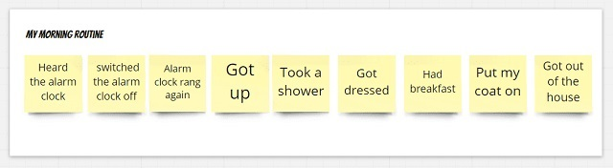

The steps of a morning routine

All these are *past events*.

Events will also happen *in the future*.

If you imagine the next weekend, for example, you may wish to have done the following stuff by Sunday:

* played with your kids,
* slept for 8 hours on Saturday night,
* had a drink with friends,
* bought some groceries at the local shop,
* had a nice dinner with your partner,
* watched the next chapter of your favorite series.

**Event storming is the act of displaying these *events* on a wall.**

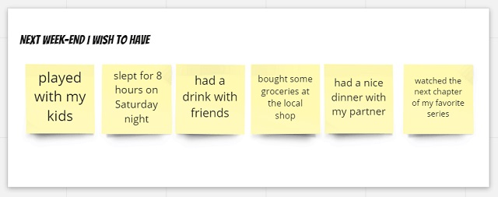

The steps of your weekend

That’s it! You’ve now understood what event storming is about!

Ok, ok… maybe you want to know a bit more, but, honestly, you already know all the basics!

**Event storming is a technique to collectively visualize events and do something from there.**

## 2.2 Why would you want to visualize events on a wall?

Like the tip of an iceberg rising above the water, events are the most visible aspects of a larger complex - but not always the most important - *Donella H. Meadows in Thinking in Systems*

Guess what? Events do not happen by magic!

To use Donella Meadows’s iceberg metaphor, once events are visible, you can look below the surface. And the system structure is what resides below the surface. **The *structure* of a system is what causes its repetitive behavior, which in turn is observed through events.**

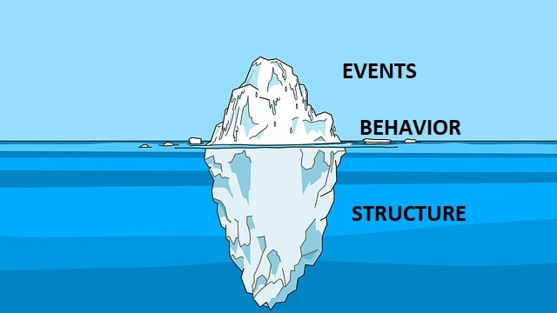

Iceberg with events at the top, bahavior at the bottom and structure below the surface

Here is an example from this morning:

* You switched off the alarm clock this morning (*event*).
* You do this 4 times every morning on average (repetitive *behavior*)
* And, guess what: every night, the concentration of caffeine in your blood is high (this concentration is one expression of the system *structure*)

## 2.3 Summary: what is event storming about?

**To summarize, when you do event storming:**

* you start by visualizing the events, *the easily observable things*
* then you dig into *behavior* and *system structures*

**Your goal can be**, at will:

* either to change an existing system for the better
* or to design a system that will allow the desired events to happen (and the undesired ones to not happen).

Hopefully, at this stage, you are starting to get a sense of what event storming is about.

In the next chapters, you will learn how to use Event Storming to **draft a software design in details**.

Later in the book, you will discover that Event Storming can also be used to **improve a workflow**

# 3 Big picture Event Storming

## 3.1 Why would you want to run a big picture event storming?

*The traditional ways to define your architecture can result in slow delivery. Use 3 simple checks to determine if Big Picture Event Storming is your #1 approach.*

### 3.1.1 Two architecture failure stories

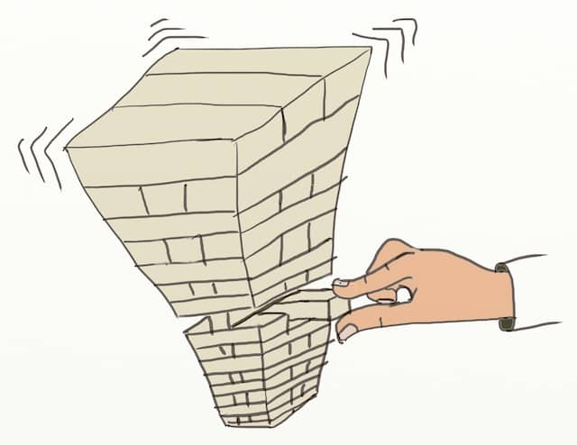

Drawing of a Jenga tower about to fall. Traditional software architecture approaches often feel like playing a game of Jenga, where any decision can cause a catastrophe.

📝 **What do we mean by Software Architecture?** Software architecture refers to the fundamental structures of a software system and the discipline of creating such structures and systems. (Wikipedia) This includes high-level requirements workshops, user exchange discussions, and domain knowledge sharing.

#### 3.1.1.1 How [big design up-front](https://en.wikipedia.org/wiki/Big_Design_Up_Front) and ivory tower architecture fail?

A few years ago, I (Philippe) worked for a bank as a contractor. I quickly noticed that everybody was talking about the PXT project. After a few more days, I understood that PXT was a massive project with an ambitious goal. The project aimed at re-designing fundamental banking abstractions through the whole information system.

Architects and business ‘visionaries’ had planned the project without involving ‘mortal’ developers. As the project moved on, this new model kept looking more unrealistic. Yet, the project lingered for a few years, involving hundreds of people. Ultimately, it was canceled, leaving wasted time and code bases in schizophrenic states.

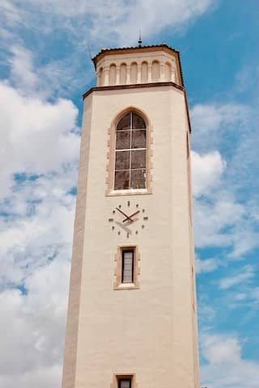

Photo of a white tower. Architecture is often done by experts alone, what we call “Ivory Tower Architecture”. Although known not to work well, this architecture strategy remains wide-spread.

This story could serve as a case study for ivory tower architecture. Indeed, as often with this kind of project, PXT was a failure:

* The system did not evolve in the desired direction. It did not deliver its promises on performance, maintainability, evolvability, operations, support…
* The project cost a lot more than the initial plan. The scope kept growing to accommodate for what was missing from the initial blueprint.
* Business experts and architects had wasted *a lot* of time trying to figure out all the details up front.
* Team members did not feel engaged in the project. They had not been involved in any decision-making. Many of them saw themselves as mere executors.

#### 3.1.1.2 How does emergent architecture fail?

If Big Up-Front Design does not work, could emergent architecture be a better strategy? In many ways, it is, but it also comes with its own issues.

Some time ago, I (Philippe) decided to learn the Ruby programming language, so I started attending Ruby meetups. Most [Ruby](https://www.ruby-lang.org/) developers work with Rails, a framework for building web applications. As I chatted with [Rails](https://rubyonrails.org/) programmers, I discovered that most were facing the same issue. As their code base grew, they all ended up crawling in a monolith of dependency.

Rails is a beautiful platform. In no time, you can set up a perfectly working website that looks great and that is thoroughly tested. Rails comes with design guidelines and an extensive test harness. Unfortunately, these are so handy that most developers overgrow their applications inside them. Nevertheless, it happens smoothly, slowly, and safely, delivering features along the way. Yet one day, they realize that new features have become incredibly slow to write!



Photo of a Lego Star Wars Stormtrooper emerging from an egg shell. Emergent architecture is another wide-spread strategy. In practice, it often looks like ‘we’ll do the architecture later’.

Here is what we observed with this kind of 100%-emergent style of architecture:

* Non-developers have no clue about what developers are doing. The code has become a big ball of dependencies. This makes it difficult to communicate any kind of status to people who don’t code.
* With enough tests and refactoring skills, developers can implement any feature. Yet, it always takes more time than expected! ‘Refactoring’ repeatedly comes up as the explanation for the extra time.

📝 Both these approaches waste time and effort and result in slow delivery!

Both emergent and Big Up-Front Design architecture are failure strategies! Should we abandon all hope?

Wouldn’t it be great if we had a magic spell to avoid these pitfalls?

It turns out **there is a middle way, and it’s called Big Picture Event Storming!**

### 3.1.2 Common symptoms

Let’s first understand the problem itself. Although these two stories sit at both ends of the spectrum, they have key elements in common!

#### 3.1.2.1 No obvious solution

Let’s reason by absurd and suppose there *was* an evident architecture:

* Architects would have found it upfront… And everything would have flowed nicely from there!
* Or the developers doing emergent design would have quickly refactored their code towards this obvious solution… And everything would have flowed nicely from there!

Our two stories did not end that way, meaning there was no evident architecture!

#### 3.1.2.2 Not a lack of skills

Nowhere in the story did we hear about people failing to do something. Improving any of the people’s skills would not have changed the story. Suppose developers get better at refactoring, and architects better at designing. Developers would have spun the refactoring wheel a bit faster. Architects might have saved 1 day of architecture meetings. Yet, the projects would have remained stuck in their failure loop in both stories!

#### 3.1.2.3 The problem persists

In both stories, the teams were trapped in a repeating loop. Whatever efforts the people put into doing-it-better-this-time, the loop repeats itself:

* Doing more design up front means more time spent on architecture and more delays. It’s also betting on the future, which means even more delays when the real-future comes to life!
* Doing more emergent design means deferring *all* clean-up for the next feature. Think of it as leaving the kitchen in a mess after cooking. This slows the delivery of upcoming features and makes any architecture change daunting.



Photo of a kitchen where everything was left as-is after some cooking. This is what the code looks like after developing a feature when we adopt extremist emergent architecture.

Whatever approach you chose, doing ‘more’ of it will not fix the challenge!

### 3.1.3 Big Picture Event Storming is the middle way!

Big Picture Event Storming puts *everyone* together to define a “Rough Up-Front Design” in 2 days.

* **Big Picture Event Storming is not trying to do everything right the first time**. Instead, it acknowledges that **it’s better to start with a rough design and improve from there**.
* **Big Picture Event Storming is not discovering everything as we go**. Instead, it acknowledges that **a bit of up-front thinking might save us a lot of time down the road**.
* **Big Picture Event Storming works best when followed with incremental and emergent design**:
* To continuously steer the codebase towards the agreed architecture vision
* While leaving options open.

We should also re-run the Big Picture Event Storming from time to time to update the vision.

Compared to traditional architecture, Big Picture Event Storming features unique benefits:

1. **Everyone will feel engaged and responsible for the decisions made during the event.**
2. Thanks to face-to-face communication, **the workshop grows common knowledge of the problem.**
3. The workshop triggers open and honest communication between everyone involved. As a result, **everybody gets a clear status of where we all stand**.

Ultimately, Big Picture Event Storming impacts the users’ lives sooner!

### 3.1.4 How do you know if Big Picture Event Storming could help you?



Photo of a corridor with many doors. There are many ways to tackle complex problems, and there is no obvious solution. Relying on the diversity of a wide-scale workshop like Big Picture Event Storming is good approach in this kind of situations.

When you face an architecture challenge, check whether the following statements are true:

1. **Does there seem to be no evident architecture?**
2. **Do the people have the skills to tackle the challenge?**
3. **Does is look like your progress has stalled despite all your efforts?**

If all these are true, try Big Picture Event Storming! This book is your guide.

## 3.2 How to prepare a Big Picture Event Storming workshop

[*Event Storming*](https://www.eventstorming.com/) *is an excellent way to get started with Functional Architecture. Here are 5 essential preparation tips to turn your first workshop into a success!*

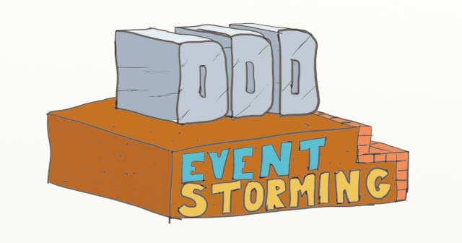

A drawing of a building looking like the 3 Ds of Domain-Driven Design and functional architecture, built on foundations written Big Picture Event Storming

### 3.2.1 Homework first!

You’ve decided that Big Picture Event Storming is the way to go, and you’re eager to start one. Not so quick, though! As with many things, lack of preparation can turn your promising workshop into a total failure.

Before anything, preparation is the key to success. (*[Wikiquotes](https://en.wikiquote.org/wiki/Alexander_Graham_Bell)*) [Alexander Graham Bell](https://en.wikipedia.org/wiki/Alexander_Graham_Bell)

**There are five key elements to prepare an Event Storming:**

* Active Sponsorship
* A Clear Scope
* The Right Audience
* An Enticing Invitation
* An Effective Briefing

Let’s go through each of these in detail.



A photo of study books and pencil. Like anything, Big Picture Event Storming requires some preparation to be a success

### 3.2.2 Active Sponsorship

At this point, the most important thing to do is to find good sponsorship. By “good sponsorship”, we mean having support from influential people. What **you want is your workshop to stop being your initiative and to become the group’s initiative**. **Getting backup from the influencers will dramatically increase your chances of success.**

Usually, **private chats with these people are the best way to win them over**. In the end, you want them to share and support a common goal for the Event Storming session. One of the first sessions we ran didn’t go very well because we had omitted this step. Some people wanted to draft a target architecture to know how to refactor in the long term. Others wanted to understand the main blocking points and identify the first wins. As a consequence, the session was disappointing. ☹

### 3.2.3 A clear Scope

With a clear goal in mind, you should have a rough idea of the scope of the session. Event Storming is an exploratory activity. People who are not used to it will feel a bit lost at first. We found that **it’s better to boot the workshop around 1 or 2 uses cases makes people more comfortable.** So, chat with your sponsors or other domain experts to agree about these use cases before the session.

As we said, Event Storming is exploratory by nature. Discussions about these use cases will bring in other concerns during the session. It will be up to the group to decide whether to add them to the scope or not. It’s ok to start with clear and specific use cases; there’s no need to be afraid to miss things out.

It’s also a good idea to **identify a first** [**domain event**](https://martinfowler.com/eaaDev/DomainEvent.html). It will both serve as an example and a way to trigger the Event Storming. From experience, this event should be somewhere in the middle of the story. It should also be clear enough for everybody to understand. Examples:

* “A trade was booked”
* “An order was paid”
* “A room was booked”

Don’t worry if you wonder what a domain event is; we’ll get into the details later.

### 3.2.4 The Right Audience

It’s time to list the ideal audience. As a rule of thumb, we found that **sessions work better with a mix of 50% of domain experts and 50% of technical people**.

With too few domain experts in the room, the workshop becomes a one-way teaching lesson. Ideally, we’d have experts for all the bounded contexts you foresee in the scope of the workshop.

We also need to **have a fair share of technical people in the workshop. In the end, it’s their domain knowledge we want to grow**. Don’t forget that, as <https://twitter.com/ziobrando> says:

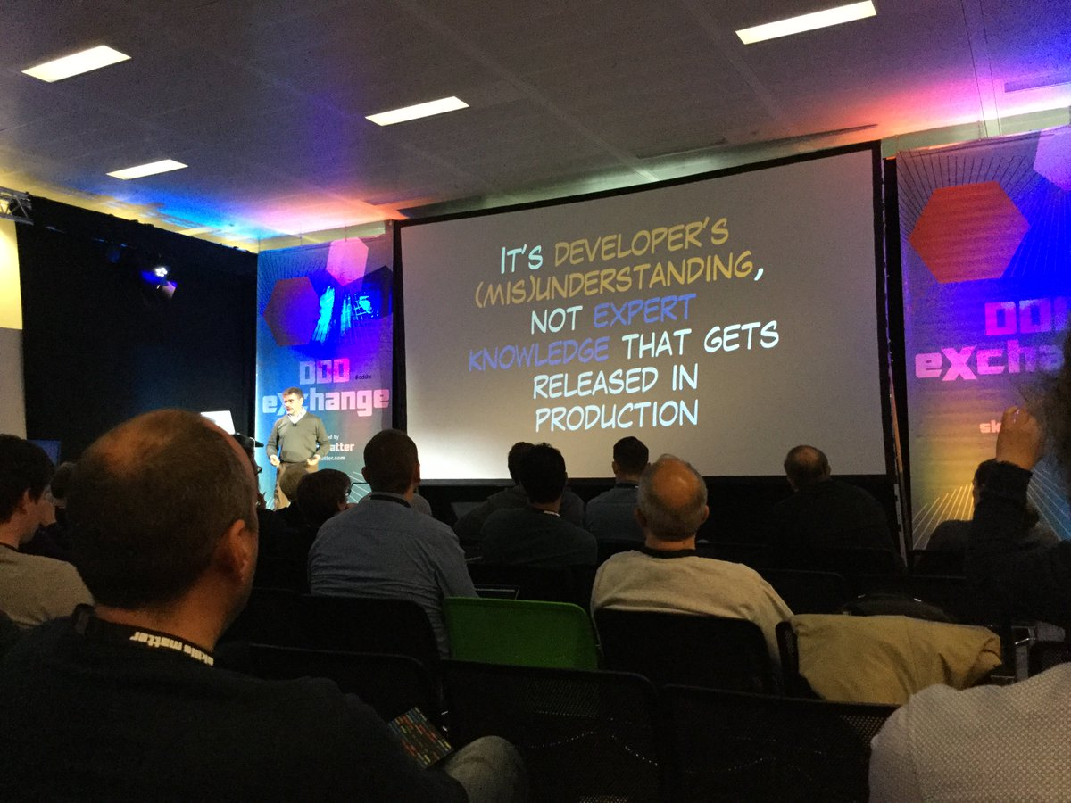

A photo of Alberto Brandolini during a conference, with a slide “It’s developers (mis)understanding, not expert knowledge that gets released in production”

Original Tweet from [Mariusz Gil](https://twitter.com/mariuszgil/status/857924761497866242)

Try to maximize the diversity of technical roles to create buy-in. One of the critical advantages of Event Storming is that it scales to a large audience. If possible, **send a call for volunteers among teams to make sure everyone feels welcome**. This will increase buy-in even further.

### 3.2.5 An Enticing Invitation

By now, you should have sponsors, a clear goal, a few starting use cases, and the ideal audience. The next thing to do is to send enticing invitations. Your organization’s culture will define the level of effort needed to get people to attend. Maybe a simple email will be enough, or perhaps you’ll need to meet everyone in person to have them present.

**Make sure that the sponsorship is visible in the invitation to maximize buy-in.** For example, ask an influential sponsor to send the invite for you.

**If you can, sketch a visual invitation. This will set the tone for a different kind of architecture meeting.**

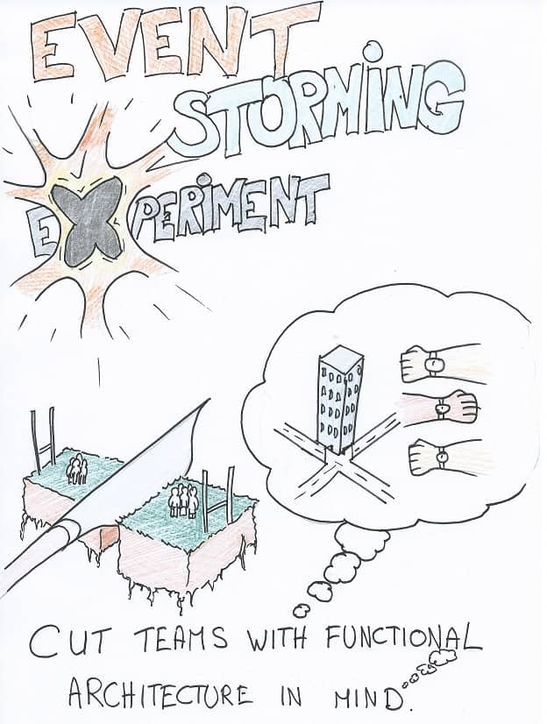

A real visual invitation we drew for a practice session of DDD Big Picture Event Storming

### 3.2.6 An Effective Briefing

When you have your final list of attendees, **brief them about the goal of the workshop**. This helps people in many aspects:

* To understand that the goal is worth their time
* To be ready for the initial disorientation
* To get an idea of how the session will go
* To get answers to quick questions

We found that **a quick 15 to 30 minutes gathering works well**, but again, you might need to adapt to your organization. For example, groups that are used to written communication might prefer email, chat, or wiki. What is important is that people can ask questions and get answers.

### 3.2.7 On good tracks!

If you follow these steps, your Event Storming session is already on good tracks! Let’s now see how to prepare the room for a successful session.

## 3.3 How to prepare the room for a Big Picture Event Storming

*Running a Big Picture* [*Event Storming*](https://www.eventstorming.com/) *is a great way to kick start a project. Fortunately, it only requires standard supplies. Here is a detailed checklist.*

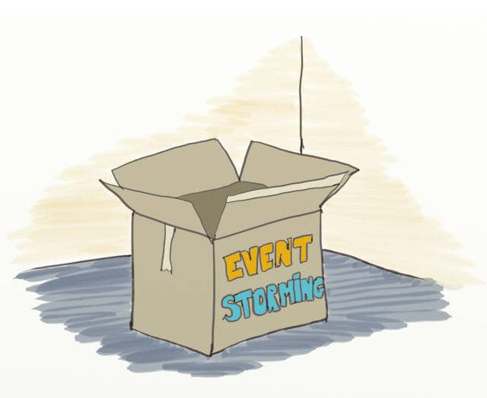

An cardboard box written ‘Event Storming’. It’s opened in an empty room in preparation of a DDD Event Storming

Before we jump into the actual animation, here is the material you'll need:

* A Visual Agenda
* A long wall
* A long strip of paper
* Stickies
* Sharpies
* A Small Table
* Food

📝 **What if we are remote?** Obviously, this only applies to physical Event Storming workshops. The supply list will be very different for a remote Event Storming. You’ll find more details in the Remote Event Storming chapter.

### 3.3.1 A Visual Agenda

One critical thing to prepare before the session is a [Visual Agenda](https://gamestorming.com/visual-agenda/). As we explained, participants may feel destabilized by the mass of information and ideas that emerge during an Event Storming. To help them through, **before the session begins, stick the Visual Agenda on the room's walls. Participants will know when they enter that they are here for a different workshop**. Also, walking them through the various steps of the Visual Agenda before they start will reassure them. It's also **an excellent way to highlight the few rules of Event Storming**.

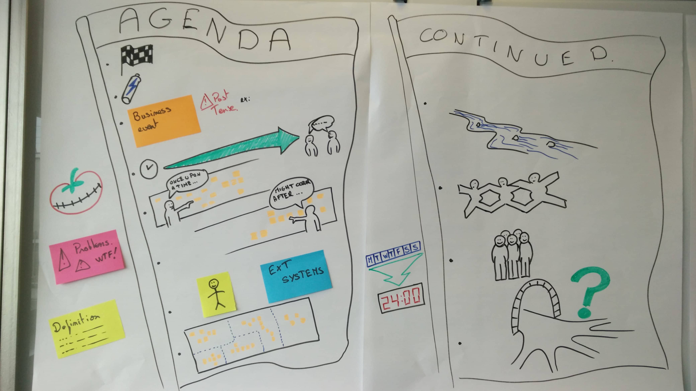

A Sample Visual Agenda for a full length DDD Big Picture Event Storming session

You can find explanations about how to prepare a Visual Agenda in the GameStorming [book](https://www.amazon.com/Gamestorming-Playbook-Innovators-Rulebreakers-Changemakers/dp/0596804172/ref=sr_1_1?ie=UTF8&qid=1544163919&sr=8-1&keywords=gamestorming) or [website](https://gamestorming.com/visual-agenda/).

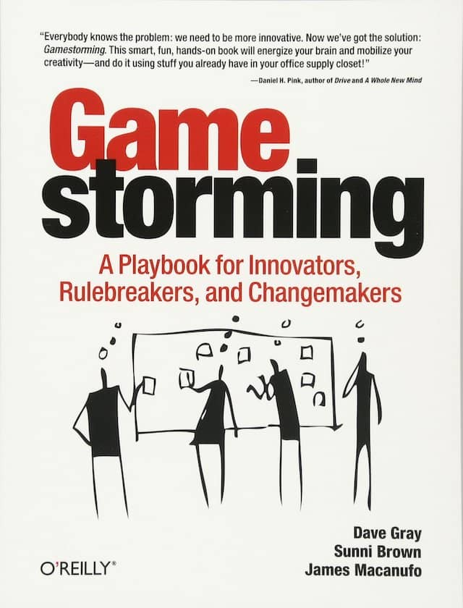

Cover of the Gamestorming book. This book contains a guide to create a visual agenda for your workshop. It was also one of the inspirations for the Event Storming workshop itself.

You must be wondering what the steps actually are. Don't worry; we'll cover this just after. For now, here is a list of other supplies you'll need to run an Event Storming workshop.

📝 Event Storming can be a somewhat destabilizing workshop. A Visual Agenda will reassure first-time attendees.

### 3.3.2 Infinite Design Space

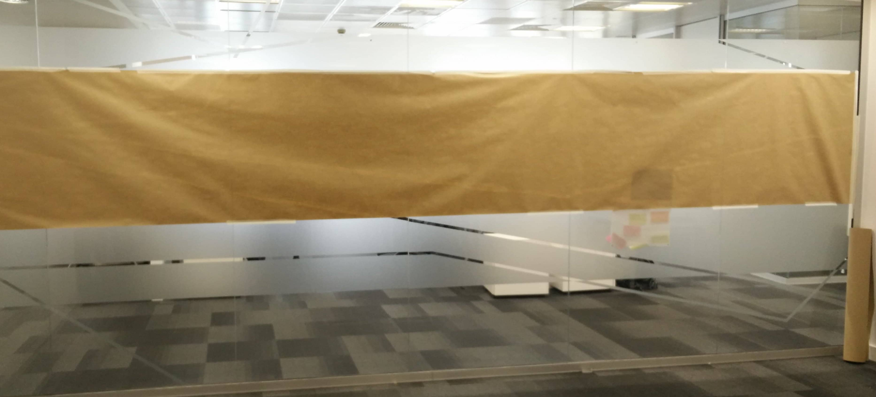

A photo of a very large design board spread on the wall. There is also extra paper roll to increase the design space if needed. DDD Event Storming requires a lot of design space to let us envision anything we want.

By far, **the most challenging thing to find is a big enough wall to do the workshop!** [Alberto Brandolini](https://twitter.com/ziobrando?lang=en), the inventor of Event Storming, recommends an 8 meters long wall. **Having an 'infinite' design space has two benefits:**

* **Participants won't constraint their ideas**, creativity, and visualization to the available space
* **Participants will have enough place walk around and collaborate** at will

If you have a large enough room, this should be your first choice. Alberto says that corridors can be good candidates too. My own experience with this was disappointing, though. Participants complained about other people coming and going all the time.

Once you've found a room, you'll need a large paper roll to place your stickies on. **Using paper instead of the wall makes the workshop 'movable.'** This way, you will be able to add more design space if you need it. You'll also be able to stick it in your workplace for a few days after the workshop if you want.

### 3.3.3 Stickies

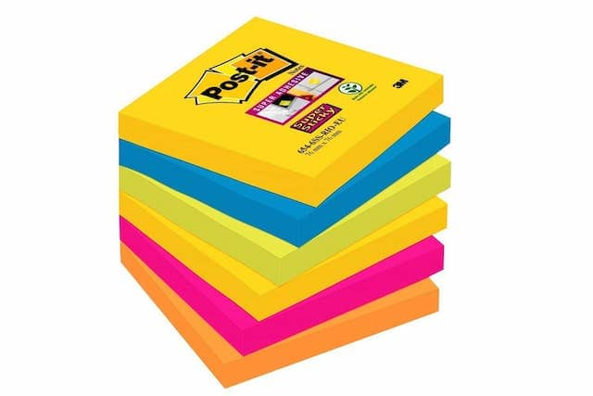

A stack of stickies. DDD Event Storming makes a very heavy usage of stickies. Some even say Event Storming was invented by 3M to sell more Post-Its 🤣

**Event Storming consumes a tremendous amount of sticky notes, especially orange ones, for domain events!** To summarize, you'll need:

* Many orange stickies, around one stack per person
* pink stickies
* large yellow stickies
* small yellow stickies
* blue stickies

Each color has a specific meaning in the Event Storming legend. We'll see how these are used later.

### 3.3.4 Sharpies

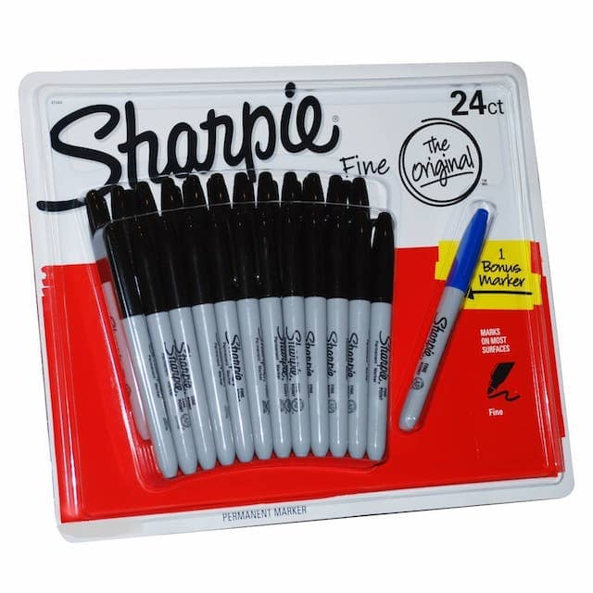

A box of sharpies. Sharpies markers are great for writing on Event Storming stickies because they let us write just the right amount of words.

Obviously, **people will need something to write on the stickies. Sharpies or small markers are the best**. They are readable from a few meters but still let you write enough words on a single sticky.

### 3.3.5 No Chairs

Typical meetings are boring and get people sleepy. In comparison, a successful Event Storming workshop keeps people energized and productive. **Removing chairs and meeting tables in the area helps people to stay energized**. However, we don't want Event Storming to become a slow torture session either! This means **you'll need to schedule enough breaks**.

### 3.3.6 A Small Table

We'll need somewhere to place our supply of stickies and sharpies. A small table will be the final addition to our setup.

### 3.3.7 One last thing… food!



Photo of a few cookies. Food is a great addition to a DDD Event Storming. Attendees will praise you for it.

If you can, bring some [food and drinks](https://philippe.bourgau.net/how-we-increased-productivity-by-25-with-a-fruit-basket-at-work/). **The workshop can be tiring; having food around sustains participants' energy longer**.

📝 We beg you to bring food to avoid #DeathByEventStorming

### 3.3.8 Everything is ready!

By now, you should have everything ready to run your first Event Storming! Let’s walk through a typical workshop.

## 3.4 What to say at the beginning of a Big Picture Event Storming

*Congratulations! 10 or more people are now in the room looking at you, wondering how to get started… Don't panic: here is your briefing script.*

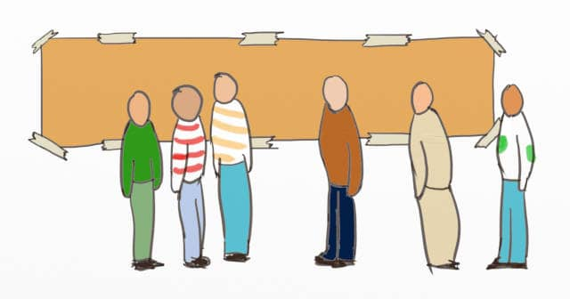

Drawing of people discussing in front of an empty design Space. This is what a Big Picture Event Storming session looks like before it starts.

Your Big Picture Event Storming briefing should introduce:

1. The general goal
2. The scope and use cases
3. What a domain event is
4. What a domain definition is
5. How to record questions and problems
6. And a few simple rules to ensure the success of the workshop

Here is how we usually start our Big Picture Event Storming workshops

### Introduction: why and who

Thank you for being here. I'm <*your name*>, and I will be your facilitator during this Event-Storming workshop. Before you start, let me share a few guidelines.

**The primary outcome of this Event-Storming workshop is the shared knowledge between domain experts and developers**. That is why

$$Name$$

,

$$Name$$

and

$$Name$$

are here, as domain experts and

$$Name$$

,

$$Name$$

and

$$Name$$

, as developers.

You'll build on this shared knowledge to draft a target architecture, but it can also help you make many other complex decisions.

Now that you know who is here and what this workshop’s goal is, let’s see how it will go.

### Scope and use cases

Today, you'll cover <*your scope*>. To make things more concrete, you'll explore the following use-cases <*list your use cases*>.

### Domain Events

You will start by identifying domain events that happen during these use-cases, such as <*your 1st event*>. A Domain Event is simply something that happens in your system.

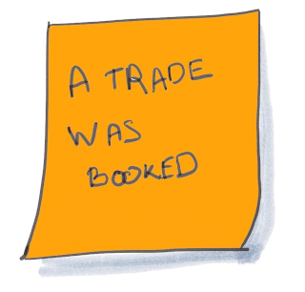

Drawing of a Domain Event orange sticky written “A trade was booked”. Domain Events are the main building blocks of a Big Picture Event Storming

As you can see in this example, **you will use orange stickies to write events using past tense. This is a grammatical trick to create meaningful events**. Events are not actions of someone (not "The trader books the deal"). Even though some events will result from actions, we are not interested in actions yet.

**Here are a few more points to help you understand what domain events are**:

* They are not technical and should not be specific to your system's implementation
* You could read about them in domain books
* Domain experts understand them

When we use the word domain, it means the specific topic for which the system is developed. In your case, the domain is <*your domain*> (ex: trading book)

**When identifying the events, you will be able to organize them in chronological order on this enormous piece of paper that you see on the wall**.

### Domain Definitions (aka [Ubiquitous Language](https://martinfowler.com/bliki/UbiquitousLanguage.html))

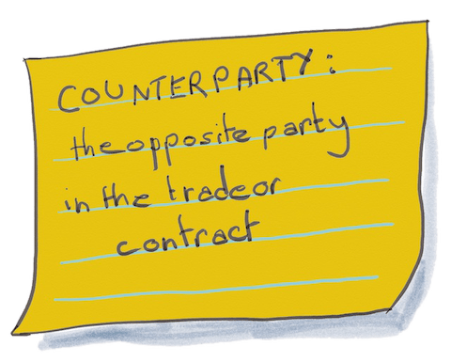

Drawing of a Domain Definition yellow sticky written “Counterparty…”. The Big Picture Event Storming workshop is a great way to capture the definitions of the important words in your business domain, and to grow your Ubiquitous Language

**Whenever you come across or agree on a domain word that may be confusing, feel free to define it on a large yellow sticky**

**Writing down the domain definitions is like building your own dictionary of what the words mean in your context. It is also called the domain’s ubiquitous language**. This is very useful to prevent misunderstandings between all of you by making things as explicit as possible. This, in turn, improves how you work in many different aspects (ex: when choosing what to build or even refactor). Remember: the primary outcome of this Event-Storming workshop is shared knowledge.

### Problems

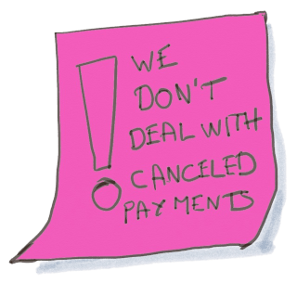

Drawing of a Problem purple sticky written “A trade was booked”. Many problems and questions usually come up during a DDD Event Storming workshop

Likewise, **you will use purple stickies to park "problems." Whenever you encounter**:

* a question you cannot answer
* something that does not seem right
* or any problem you should look into

Record it on a purple sticky.

### Last things to know before starting

Before we look at the detailed agenda, here are **5 crucial things that you should know**:

1. You must stick to domain language to keep this collaboration alive. **We've seen Event Storming sessions drifting into technical discussions; this leads nowhere.**
2. Event Storming is a visualization technique. Make sure you capture the topic that you are discussing on a sticky. **Remember that you should never be talking about something not yet displayed on the wall.**
3. Remember that **Event Storming is a way to shrink months of** [**Big Design Up Front**](https://en.wikipedia.org/wiki/Big_Design_Up_Front) **into a few days!** It's going to be intense, but you'll accomplish a lot in a short time.
4. Event Storming might feel chaotic. It might be rocky and go in unexpected ways at times, but we will adjust. **At the end of the day, though, the success mainly depends on how much you all want it!**
5. Finally, to **keep the workshop pace sustainable**, we'll take a 5-minutes break every 50 minutes.

### 3.4.1 And then what?

Once this introduction speech is over, we quickly present the different steps of the workshop.

## 3.5 Step by Step Guide to run your Big Picture Event Storming

*From energizing the audience to reading the story of your domain, here are all the steps that you will go through during a Big Picture Event Storming.*

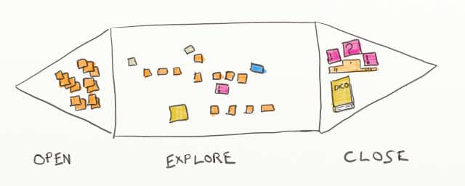

Drawing of an Big Picture Event Storming board blended in the 3 Gamestorming steps: open, explore, and close

Finally, we are getting to the real thing!

We already went over the preparatory work for a Big Picture Event Storming. So now that we have everything ready, let's see how to run this a workshop in practice!

Here are the 9 steps of an Event Storming

1. Preparing the Room
2. Energizing the audience
3. Briefing and Presenting the Agenda
4. Generating Domain Events
5. Sorting Domain Events
6. Adding Actors and External Systems
7. Storytelling
8. Reverse Storytelling
9. Closing

### 3.5.1 Preparing the room

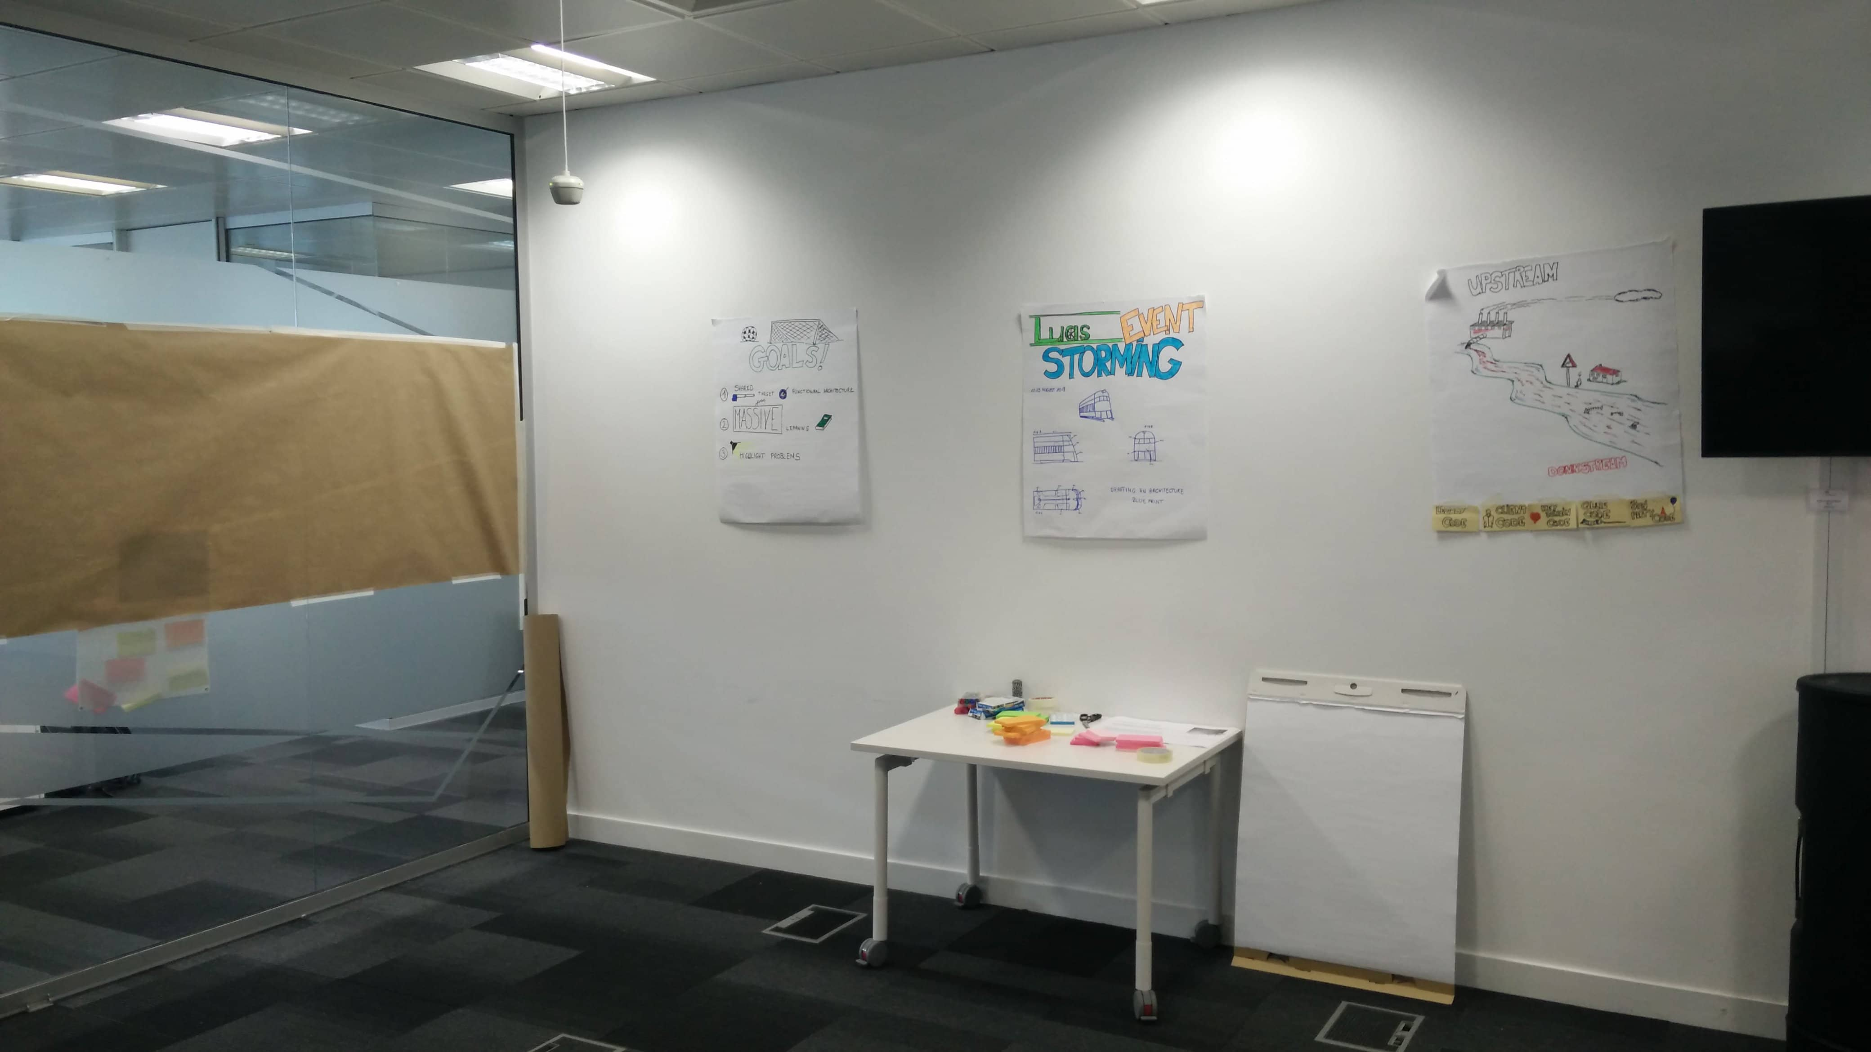

Photo of the room setup before the Big Picture Event Storming session starts.

You want to have the room ready when participants arrive. **Come to the room 30 minutes early to prepare it for the workshop**. How to prepare the room for a Big Picture Event Storming has all the room preparation details. Roughly, this includes:

* Removing tables and chairs
* Sticking the design paper to the wall
* Sticking the Visual Agenda to the wall
* Laying down the rest of the material somewhere

### 3.5.2 Energizing the audience

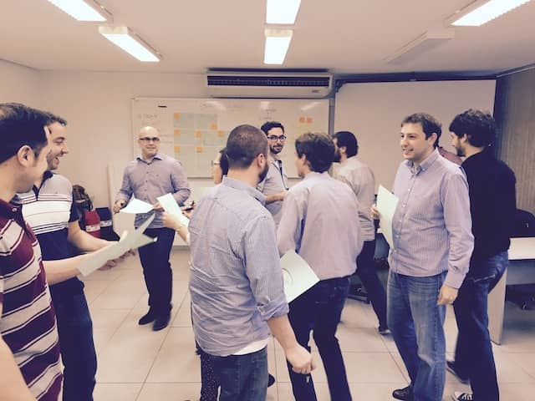

Photo of participants during an Collaborative Face Drawing energizer. Energizers are important to set the tone before a Big Picture Event Storming

Picture from [funretrospectives.com](http://www.funretrospectives.com/)

As we've already said, Event Storming is a different kind of architecture meeting. Our advise is to **run a collective physical energizer to get people out of their habits and raise engagement**. You can find many great physical energizers at [funretrospectives.com](http://www.funretrospectives.com/category/energizer/). We've had success with many of them.

### 3.5.3 Briefing and presenting the plan

**Now is the time to present the workshop to the participants. Start with the goal, scope, and use cases**. It's the right moment to explain the step participants will go through and how each step will help them to reach their end goal. A visual agenda helps a lot here. It's also an excellent time to introduce some general conventions. You can find a sample briefing script in What to say at the beginning of a Big Picture Event Storming.

### 3.5.4 Generating Domain Events

This is when the workshop actually begins. **Ask attendees to stick as many** [**Domain Event**](https://martinfowler.com/eaaDev/DomainEvent.html)**s related to the use cases as they can think of**. To help them get started, be the first to place the Domain Event you prepared in the middle of the design space.

📝 [Alberto Brandolini](https://twitter.com/ziobrando)’s trick: ignite the Event Storming by sticking a prepared domain event on the design board.

At some point, you'll see that the rate of Domain Event generation will dwindle down. That's the sign that it's time to move on to the next phase. 25 minutes or so are usually enough for this first phase.

### 3.5.5 Sorting Domain Events

This is when Event Storming really starts. Simply **ask participants to sort the events chronologically**.

The goal is to represent the workflow on the design board. During the previous generation phase, people worked alone to write any event they could think of. This is going to change! They'll now need to speak to each other to sort the events.

This is where Event Storming does its magic. Likely, attendees have different points of view about the system. They materialized these with event stickies on the design board. Next, they will need to sort out their various points of view to order the events.

📝 Event Storming does its magic when people try to sort all the events.

This phase should trigger intense discussions. Take the opportunity to nudge participants into capturing domain definitions and problems to look into. For example:

* If someone wrote an event "Artifact created" ask what an artifact is. Either they'll find a better work, or they'll write a definition for what an artifact is
* **As a facilitator, don't hesitate to ask the dumb question no one dares to**. If an event is written "Calculation result sent" ask "What calculation? And what Result?"

The idea is to make everything that is implicit explit!

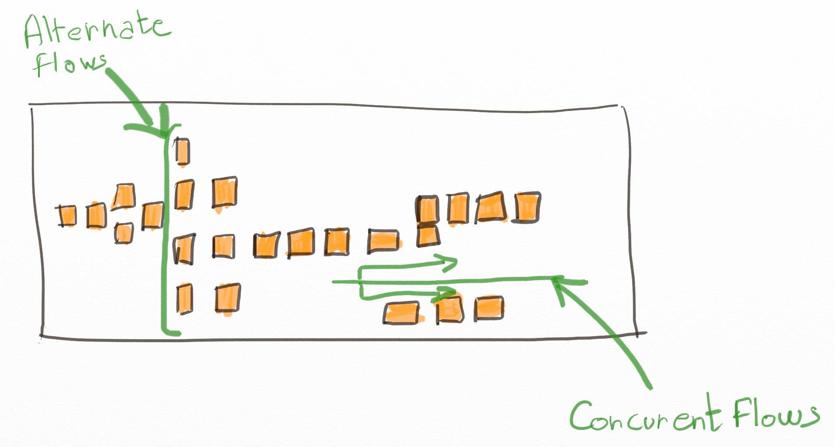

Drawing of a Big Picture Event Storming board with vertical and horizontal flow patterns. Vertical alignment models branching, while horizontal alignment models concurrent flows.

As they'll arrange the stickies in chronological, participants will identify alternate flows, or things that can happen concurrently. Invite them to **use swimlanes or vertical alignment** to represent these situations.

### 3.5.6 Adding Actors and External Systems

You should start to see the story of your system emerge. All good stories have heroes, though! This time, **ask attendees to identify actors (people with a role) and external systems (ex: an online API) that trigger or respond to events**.

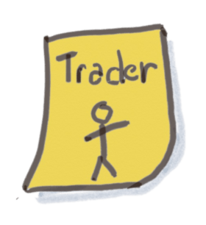

Drawing of an actor sticky for Big Picture Event Storming. It’s a small yellow sticky with the role written on and a stick figure drawn on.

Nothing would happen if no human interacted with the system. The convention is to use small yellow stickies for actors. There is no need to add an actor to every event; sticking one at the beginning of a chain of events is enough.



Drawing of an external-system sticky for Big Picture Event Storming. It’s a blue sticky with the external system’s name written on.

Similarly, your system also interacts with external systems. The convention is to use blue stickies for external systems. Just stick them where the events interact with the external systems.

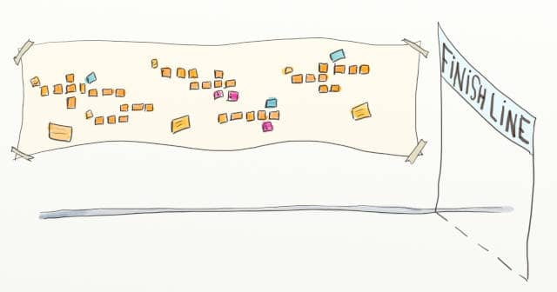

Drawing of a Big Picture Event Storming board with a running race finish line.

You're getting close to the end! All the attendees should now have a good grasp of the big picture of the domain. So let's test this understanding a bit.

### 3.5.7 Storytelling

It's time to check that the whole picture makes sense. Since the beginning of humanity, stories have been the vehicle of knowledge. Knowledge used to go from generation to generation through campfire stories. As a result, [our brains are hard-wired to listen, remember and make sense of stories](https://blogs.scientificamerican.com/guest-blog/it-is-in-our-nature-to-need-stories/).



Made up image of a giant open book in the middle of the countryside. Storytelling is key to successful Big Picture Event Storming

Ask for volunteers from the audience. The first **volunteer is to narrate the story of the system by going through the events chronologically, explaining what is happening**.

As the narrator speaks, the audience will raise questions and notice incoherencies. This is yet another opportunity to add, remove or replace events to improve the story. More definitions might emerge too. If a problem seems too big to fix during the session, park it with a pink "problem" sticky.

Narrating the story can be tiring, so ask a new narrator to take over at some point.

### 3.5.8 Reverse storytelling

Reverse storytelling is an optional phase that is great at drilling down deeper in the domain. Get a few more volunteers and ask them to tell the story from the end. The idea is to **repeatedly ask: "What might have triggered this event?"**. This will generate or update events, actors, or external systems.

This question triggers the creative parts of our brains, leading the participants to imagine many new possibilities. This phase is very productive and brings many insights.

### 3.5.9 Closing



Photo of a man walking on a path in the mountain, taken from behind. The Big Picture Event Storming opens up a lot of opportunities and is just the beginning of the path.

You've reached the first milestone of the Big Picture Event Storming! It's time to settle down and assess the outcomes:

* **Participants have built shared understanding of the domain. This will save a tremendous amount of time by improving collaboration.** In addition, it will avoid specification bugs and lead to better design.
* **Participants have identified problems**. Fixing these problems often results in quick wins with high payoffs.
* **Participants wrote down the first definitions of their** [**Ubiquitous Language**](https://martinfowler.com/bliki/UbiquitousLanguage.html). They will leverage it to speed up onboarding and maintain the system's integrity.

### 3.5.10 What's next?

So here is what you should do at this point:

* **If participants have discovered a high return on investment problem to fix, that's what they should do right away.** In [his book](https://leanpub.com/introducing_eventstorming), [Alberto Brandolini](https://twitter.com/ziobrando) recalls such a situation. The "Big Boss," who was in the workshop, asked everyone to stop what they were doing until they had fixed a major problem that they had just uncovered!
* But, most importantly, you should leverage the collective intelligence to continue the workshop further. **For example to draft a target functional architecture, to organize teams, to decide to rewrite or refactor, etc.** We'll explain how to do this in the following chapters.
* Also, participants can continue to grow the ubiquitous language by adding and refining definitions
* Whatever you decide, don't end the workshop without an agreement and someone responsible for the next steps, though.

Don't forget to ask for feedback on the session before people leave. A [ROTI](https://www.stickyminds.com/article/roti-method-gauging-meeting-effectiveness) is a quick way to do this.

### 3.5.11 Doors open!

That's it! **In a few hours, you've used Big Picture Event Storming to harness collective intelligence**. The massive sharing of knowledge is the foundational step for making complex decisions in minutes instead of weeks!

You now know everything to start a Big Picture Event Storming. So don't wait for more and start preparing for your first workshop!

Let’s see how to continue the Big Picture Event Storming to draft a functional architecture!

## 3.6 Improve collaboration with a Functional Architecture vision draft

*Lacking a shared functional architecture vision results in miscommunication and conflicting-work wastes. Here is how to quickly draft this architecture on the Event-Storming board.*

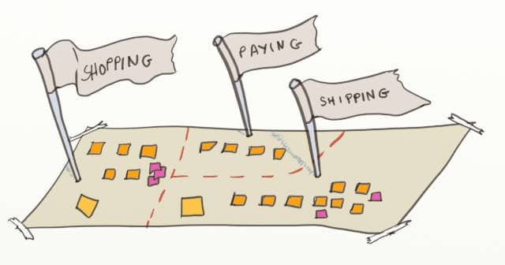

A drawing of a Big Picture Event Storming design board displayed as a land map, with flags pined in the different bounded contexts

In the ancient myth of the [Tower of Babel](https://en.wikipedia.org/wiki/Tower_of_Babel), God punished humans for their pride by making them all speak different languages. As they couldn't understand each other anymore, humans gave up building the tower, and it was never built.

**Did you ever think that people you work with all speak different languages?** Are people pulling in different directions? Do you witness misalignment between the technical concepts mentioned by developers and domain concepts mentioned by domain experts? Do changes require an ever-increasing number of people to get involved? Do you suffer from miscommunication delays?

If the answer is yes, you and your team might be lacking alignment on a shared functional architecture vision! **A shared architecture vision is a key to a sustainable, effective, and evolutionary design.**

We explained how to run a Big Picture Event Storming in the previous chapters. **Drafting an architecture vision is one of the most valuable and quick outcomes of a Big Picture Event Storming**. A shared functional architecture vision is a way to identify boundaries within your Tower of Babel. Within these boundaries, domain and technical experts will use the same language. Overall, translation between languages will be fewer and more explicit.

We'll cover the topic in 4 steps:

1. A Step by step way to draft a functional architecture vision
2. What does a functional architecture vision draft look like?
3. Why it's easier with a Big Picture Event Storming
4. 5 reasons why a functional architecture will improve collaboration

### 3.6.1 Step by step way to draft a functional architecture vision

Here is what the design board should look like if you started the Big Picture Event Storming:

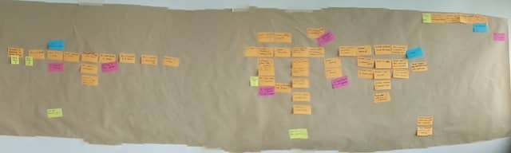

A picture of a Big Picture Event Storming board where domain events have gathered in clumps

This is where Event Storming is magic! As you can see, [Domain Events](https://martinfowler.com/eaaDev/DomainEvent.html) and other stickies gather together in groups. Let's call these groups "proto functional area." (Note: The Domain-Driven Design community, from which the Event Storming workshop emerged, calls functional areas "[Bounded Contexts](https://martinfowler.com/bliki/BoundedContext.html)." To stick to the known terminology, we'll use the term "Bounded Context.")

📝 Bounded Contexts are the most essential part of Domain-Driven Design. Keeping the different bounded contexts decoupled makes large systems simpler.

Starting from this design board, here are 6 steps to explicit the bounded contexts:

1. Find a volunteer.
2. Put the following in your pockets:

* Some colored and thick wool string
* Some scissors
* Some adhesive tape

1. Ask the volunteer to walk the board from left to right and suggest the bounded contexts on the board.
2. For every suggestion, a discussion should follow. In the end, the **participants need to agree on the bounded context boundaries. Shared domain understanding usually makes this agreement fast**.
3. Once an agreement is reached, use the wool string, scissors, and adhesive tape to delimit the bounded context on the design board.
4. Now that the bounded context is visible on the board, you can **ask the audience for a bounded context name**. Yet, naming is hard, so here is a tip: words ending with "ing" often make good names (ex: accounting, ordering). But, again, stick to terms that you would find in a book about the domain.

📝 Wool, scissors, and adhesive tape are all you need to draw bounded contexts on an Event Storming design board.

As you go through these steps, you might stumble upon a few domain definitions. So **keep your definition stickies at hand and be ready to capture this new vocabulary**.

One last word, be ready to go back and forth between these 6 steps as you progress.

### 3.6.2 What does a functional architecture vision draft look like?

An architecture vision draft is simply a map of the domain's [bounded contexts](https://martinfowler.com/bliki/BoundedContext.html).

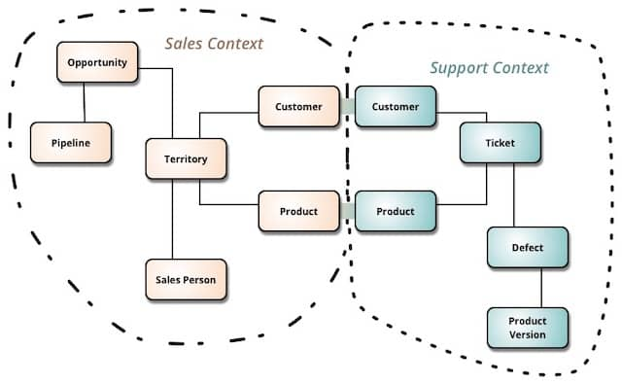

A sample map of Bounded Context (aka Context Map).

Picture from [Martin Fowler’s website](https://martinfowler.com)

So before closing the workshop, **take a few minutes to capture the map on a sheet of paper. It might really just look like a bunch of potatoes with names**. Don't worry: we'll see how to decorate this map in future chapters.

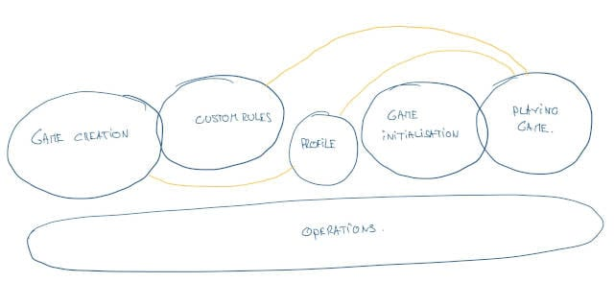

Quick sketch of a functional architecture made of potatoes looking shapes. Once bounded contexts have been identified on the board, it’s easy to draw them on a sheet or paper and to add lines or overlaps on obvious communication borders. Such a drawing is a quick and easy to way to share what was done during the Event Storming.

### 3.6.3 Why it's easier with a Big Picture Event Storming

Continuing your Big Picture Event Storming with drafting your target architecture is very easy for two reasons:

* **Event Storming creates enough shared knowledge to feed the design brainstorming**
* **We can draw the target architecture vision on the Event Storming design board**

So, just add an architecture drafting step to the Big Picture Event Storming agenda we presented before.

### 3.6.4 Five reasons why a functional architecture will improve collaboration

#### 3.6.4.1 Specific vocabulary within each Bounded-Context

As you discover your bounded contexts, you'll find that each has its own vocabulary! The nice thing about this is that every word has a precise definition inside a bounded context. So **when people discuss concepts that are inside a bounded context, they can rely on this vocabulary to avoid a lot of misunderstanding**.

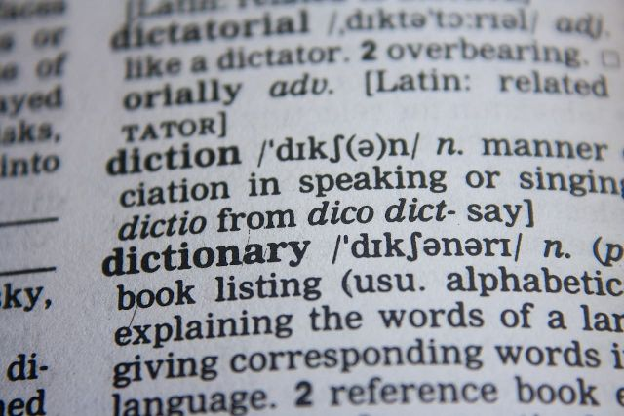

Photo of a dictionary page. Drafting the functional architecture will help you to aggregate bounded context specfic dictionaries that will improve communication.

You can even decide to **document a 'dictionary' of the words in each bounded context**. This is of tremendous help for new joiners. But it's also an occasion to make your [ubiquitous language](https://martinfowler.com/bliki/UbiquitousLanguage.html) (as this is called by the Domain-Driven Design community) more explicit.

#### 3.6.4.2 Contexts make good candidates for teams

Bounded contexts follow the natural domain boundaries of your system. **By mapping teams to bounded contexts, teams will have more effective internal communication and less need to synchronize with other teams**.

#### 3.6.4.3 Contexts make good candidates for services

The same goes for services! Because domain concepts are very stable through time, **APIs of services built on top of Bounded Contexts will change less often**, resulting in simpler versioning.

#### 3.6.4.4 More effective exchanges



Photo of a group of people sitting around a table and collaborating around large sheets of paper. A lot of domain knowledge will be exchanged during the Event Storming and architecture draft, this will help collaboration further downt he road.

Everyone collaborated and contributed to drawing the map of bounded contexts. As a result, **everyone will leave the workshop with the foundational knowledge to have deeper and faster exchanges**.

For example, developers will understand faster and better what domain experts need. This will save both time and bugs.

#### 3.6.4.5 Vision for how to split the code and evolve the architecture

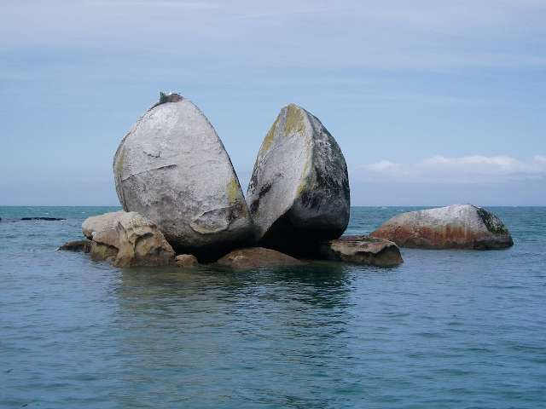

Photo of a large rock that is split in two. The shared vision of the map of Bounded Contexts lets all developers nudge the code in this direction whenever they have the occasion.

Developers are constantly changing the system design and architecture. If they disagree on the ideal architecture, they will keep nudging the system into contradictory directions. However, **once all developers share the same vision, they will evolve the code coherently**. This means less time will be wasted in '2 steps forward and 1 step backward…' refactoring.

### 3.6.5 What about YOUR team's architecture vision?

If you face the Tower of Babel challenge in your team, we strongly suggest you run a Big Picture Event Storming as soon as possible!

The goal of this book is to demystify the workshop. So take your time to follow the steps to run your first Event Storming. The gains will last for the whole life of your product!

## 3.7 Decide to Build or Buy with Big Picture Event Storming

*Extend Big Picture Event Storming to classify your bounded contexts and make high return on investment decisions, like stopping to build what you should buy!*

In Improve collaboration with a Functional Architecture vision draft, we explained how to draw the boundaries of bounded contexts. **Not all bounded contexts are equal, though. Some have tremendous value for you, whereas others only need to exist.** [Pareto’s Principle](https://en.wikipedia.org/wiki/Pareto_principle), also known as the 80/20 rule, goes like that:

Roughly 80% of the effects come from 20% of the causes. [Wikipedia](https://en.wikipedia.org/wiki/Pareto_principle)

It applies well to bounded contexts. A small part of your code base will generate most of its value. **Thanks to Big Picture Event Storming, you will identify where to focus and what software to buy or build.**

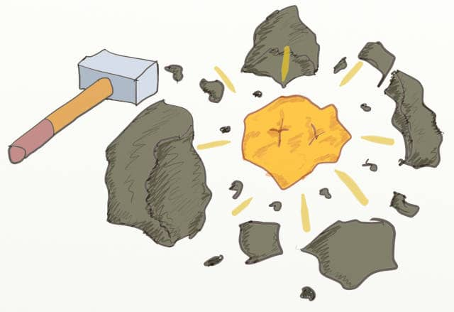

Drawing of a hammer next to a gold nugget between rocks. Using Event Storming and DDD is a good way to extract and highlight your core bounded contexts within your system

Here are a few examples:

* We ran an Event Storming with a team in Dublin some years ago. A few days after running an Event Storming with them, team members decided to descope a large refactoring that was not tackling their core. This kind of decision pays back the whole workshop many times.
* Another team we’ve worked with decided to replace a feature they were building themselves with a 3rd party. They had discovered it was “Generic.” This would allow them to re-focus on other core bounded contexts of their system.

📝 Use Event Storming to identify generic parts of your system. Then save time and maintenance by replacing them with third parties.

We’ll present this topic in 3 steps:

1. 3 flavors of Bounded Contexts
2. How to facilitate an activity to classify the bounded contexts
3. The outcomes

### 3.7.1 Three flavors of Bounded Contexts

As a reminder, Bounded Context is the Domain Driven Design name for a functional area. Also, in systems built with DDD in mind, it should be a bounded part of the codebase.

**There are 3 types of bounded contexts. Categorizing a bounded context is key to answering the “Buy or Build Software” question.**

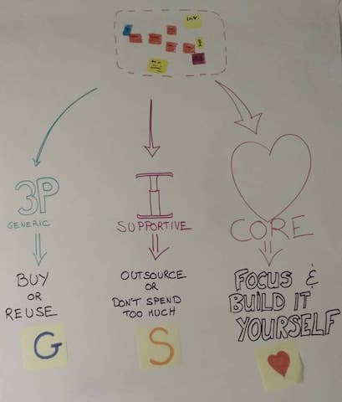

A poster that explains to the Event Storming attendees the DDD concepts of Core, Supportive and Generic bounded contexts

#### 3.7.1.1 Core contexts

**Core contexts are your most important assets. These are the bounded contexts that make your competitive advantage.** They are so crucial to your business and complex that you must build these yourself. Therefore, you must find ways to focus on them as much as possible.

To focus on core contexts, you’ll need to do as little as possible of the rest.

#### 3.7.1.2 Generic contexts

These are bounded contexts that have no specificities to your business. They are reusable across many industries. **It’s not a good time investment to build your own version.** Instead, it would be best if you reused or bought an existing third party to provide this in your system.

#### 3.7.1.3 Supportive contexts

Supportive contexts are the rest. **Too specific to buy but not differentiating enough to build any competitive advantage.** Here are typical supportive bounded contexts:

* Custom libraries that are reused across many core domains. Technical in-house frameworks are a good example.
* Features are so fundamental in your industry that everyone takes them for granted. Configuration or administration can fall here.

It’s usually impossible to reuse existing code for your supportive contexts. Yet you don’t want to focus on them either! **Here are some strategies experts recommend for supportive contexts:**

* Outsource them
* Leave them to less experienced programmers
* Or apply looser quality rules in this code
* At the same time, you don’t want them to turn into maintenance monsters!

If you want to learn more about these 3 kinds of bounded contexts, check out this [post by Jonathan Olivier](https://blog.jonathanoliver.com/ddd-strategic-design-core-supporting-and-generic-subdomains/).

### 3.7.2 Collectively classifying your bounded contexts.

As we mentioned above, **core contexts are both complex and business-critical. Technical people will know what is complex, and product people will understand what is business-critical.** They need to work together for a good classification of bounded contexts.

This activity starts after all the Big Picture Event Storming steps we presented before. Your design board should look something like that:

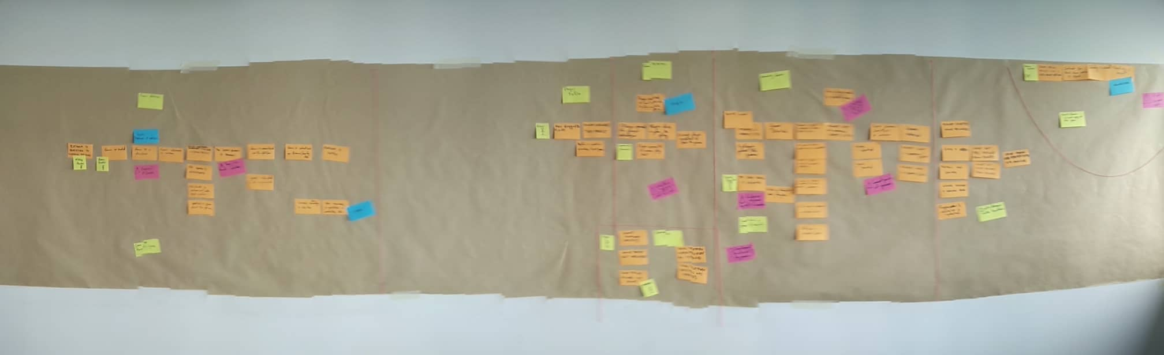

The Event Storming board after identifying the bounded contexts. Boundaries are the small red strings

Let’s see how to facilitate this activity.

#### 3.7.2.1 Introduction

Start by presenting to everyone what they will be doing.

* Give a quick introduction to the 3 kinds of bounded contexts. The concepts are simple, and people usually get them fast. A poster like the one above helps a lot.
* Also, explain that this activity aims to classify the different contexts to make better strategic decisions.
* **Explain how the final decision will be made.** For example, will the responsible person use the workshop to listen to everyone’s advice before making the final decision? Or will you commit to the group’s collective intelligence advice before leaving the room?

#### 3.7.2.2 Classification

This is the phase when **people will identify which contexts are core, supportive, or generic. Here are steps to facilitate this activity for maximum collaboration, alignment, and buy-in.**

* The best support for this activity is the [Core-Domain-Chart](https://github.com/ddd-crew/core-domain-charts) from the DDD crew.

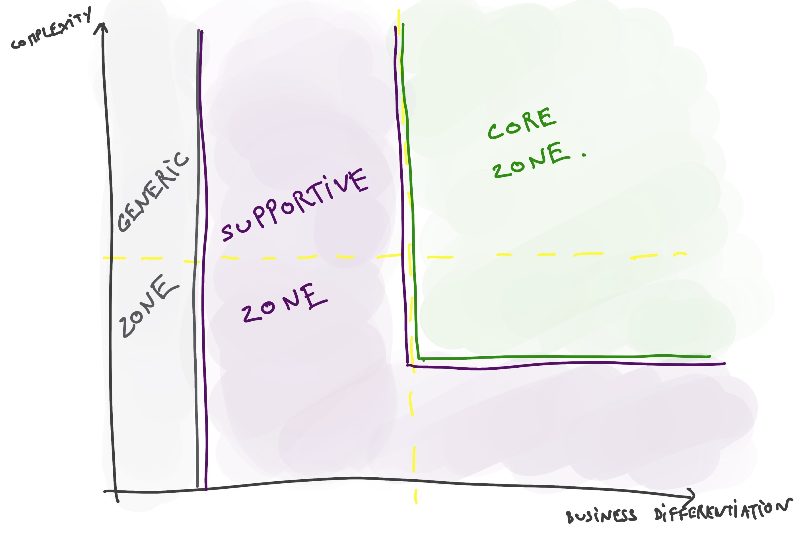

Drawing of the Core Domain Chart. This chart is very useful to classify bounded contexts, either individually, but also as a group.

* Hand over an individual template and a bunch of small stickies to everyone. Explain that you will have to place each bounded context on the quadrant. Give them 5 minutes to organize bounded contexts relative to each other.
* Now ask them to draw arrows starting from each bounded context to represent where they expect it to be in 1 year. (Use any time horizon that makes sense in your context). This should not take more than 5 minutes either.
* Give them 10 minutes to pair with people they don’t often work with and to merge their quadrants.
* Ask the pairs to pair again, forming groups of 4. Ask each group to merge their quadrant again. Grant them 15 minutes for that.
* Get everyone together again. Explain to everyone to remain silent and that you will deal with any disagreement right after. Ask every group of 4, in turn, to add one context (with its arrow) to the central quadrant.

#### 3.7.2.3 Alignment

There will likely be disagreement about the contexts. Now is the moment to sort out these points. This step might take more or less time, depending on the debate.

* Once each domain has been placed on the central quadrant, give groups 5 minutes to discuss what is on the quadrant.
* If they don’t agree with something, ask them to place a red sticky explaining the problem close to the bounded context sticky.
* Use the red stickies to create topics for workgroups. For example, copy the issue on a sheet of paper and lay it on the floor to create a ‘zone’ dedicated to this issue. The goal is now to solve all these disagreements!
  + Ask the people to self-organize in the zones.
  + People have 10 minutes to solve all the disagreements. People are welcome to move to other groups whenever they feel they don’t learn or contribute anymore.
  + Each group should update the quadrant when they reach an agreement.
  + Repeat the 10 minutes until all problems are solved

**At that point, you have classified all contexts as core, supportive, or generic.**

If you want, you can decorate the Event Storming design board with ❤️, 🅖 and 🅢 stickies. Do you remember the context map we presented Improve collaboration with a Functional Architecture vision draft? You can also decorate this one!

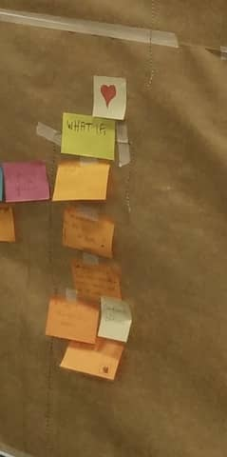

Zoom on a part of the Event Storming board where we can see a bounded context classified as core with a ❤️ sticky

### 3.7.3 The Outcomes

This simple activity can have incredible consequences. Especially for big topics like prioritization or buy vs. build software decisions. The stories we shared at the beginning of the chapter are typical examples.

A less tangible outcome is that **it focuses discussions and efforts on core contexts**. After the workshop, there will be less work on non-core contexts and more on core contexts. Work on core bounded contexts is more valuable. All in all, it means less and more valuable work: **a more profitable and** [**sustainable pace**](http://www.sustainablepace.net/what-is-sustainable-pace)**.**

### 3.7.4 Never run a Big Picture Event Storming without classifying the contexts!



Photo of crossroads of wooden walking path. If you get to that point in the Big Picture Event Storming, don’t miss on the occasion of doing this tremendous value activity!

This activity is so valuable that it would justify all the Event Storming by itself! So, whatever the reason you are running your Event Storming, **make a detour and run this two-hours activity**:

* **Everyone will share a sense of where they should focus their efforts**
* **Everyone will have had a glimpse at where the future will lead the system**
* **You will most likely discover a high return on investment actions like**:
  + Replacing in-house generic contexts by third parties
  + Reducing the complexity of supportive contexts where it makes no sense
  + Refactor or reorganize to make sure that core contexts can get your priority

The more time we spend together in an Event-Storming workshop, the faster we can make complex decisions, and the more actionable and valuable the outcome!

## 3.8 Read this before applying Big Picture Event Storming to Legacy Systems

*How to use Event Storming with legacy systems? Forget the legacy: think system's evolution.*

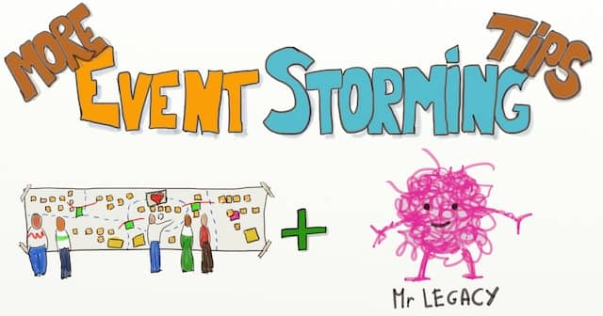

Drawing of an Event Storming board and Mr Legacy (Code) with the writing ‘More Event Storming Tips’ above

We’ve only talked about greenfield products up to now. This is fine, but **most of our work happens in Legacy Systems, doesn’t it?**

If you read this chapter, we assume you need to refactor your legacy system toward the domain. It makes sense to leverage all the benefits of Big Picture Event Storming. Unfortunately, you don’t really know how to start! Here are four tips to help you:

* Do NOT try to Event Storm your Legacy!
* Start with a 30-minute brief
* Adapt the schedule even more than usual!
* Make stress explicit

### 3.8.1 Do NOT try to Event Storm your Legacy!

It does not make sense to Event Storm what you currently have. **Legacy systems were rarely built with the domain in mind. Trying to map the existing code to domain events is a recipe for frustration and failure.** We once let this happen. The workshop drifted into an unproductive mapping of current technical dependencies. Don’t do that. Instead, use Event Storming to define a target vision.

📝 If you envision refactoring your legacy system, do as if you were starting from scratch.

You might think that we are sidestepping the topic. Our approach must tackle the core of the issue! Yet this tactic has plenty of benefits:

1. **A shared target is the first step in any change initiative.** Your team will not reach a target vision if people don’t share the same destination in their heads. Don’t spare the time to agree on a shared target. We know no better way than Big Picture Event Storming to do that.
2. **Harness the continuous evolution of the system.** Developers spend their days twisting the system in one direction or another. With a shared target, all these small changes will go in the same direction. Eventually, it will nudge the system toward the vision. (At least, it won’t pull it backward!)
3. **You are likely to find quick wins**. Some parts of the code might be easily refactored to the target. You might realize some areas are not business-critical and should be left as-is. Here is an example, We ran an Event Storming with a team that had a lot of legacy code. Two weeks later, they de-prioritized a significant refactoring. They had discovered that the code to refactor was not business-critical!



Photo of legacy factory machines. To run Event Storming to refactor your legacy system, do as if you were starting from scratch. Having the legacy in mind will parasite discussions with current problems.

On the other side, though, **it is difficult for participants to “forget” the current system**. Read on for tips to keep your Event Storming workshop constructive.

### 3.8.2 Start with a 30-minute brief

**Start with a thirty-minute brief to share the current situation with everyone**. This brief should cover business, domain, architecture, and target scope. For example, this brief should answer general questions like:

* What are the business incentives for looking into modernizing this legacy system?
* Are there some clear business constraints like specific customers, contractual or regulatory deadlines, or expected market evolution?
* Who are the users of this system?
* What problems are they currently facing when using this system?
* On the other side, what does the existing system do well?
* What kind of architecture is the Legacy System built on?
* What are the expected non-functional requirements that we expect from the future system?
* …

Event Storming would still work without this briefing. People would talk during the workshop and eventually share all the information. We just observed that it was more efficient to state what we already know.

Run a [Celebrity Interview](https://www.liberatingstructures.com/22-celebrity-interview/) or a [UX Fishbowl](https://www.liberatingstructures.com/18-users-experience-fishbowl/) to avoid a dreadful slide presentation.

### 3.8.3 Adapt the schedule even more than usual!

Here is what changes when you run the workshop with existing code:

* Some areas will already be clear to everyone
* People will have contradicting views about other parts of the system

We already said it’s good practice to use breaks to adapt the schedule. **When dealing with existing code, it becomes crucial! Use pauses to discuss with key people and agree on where to dig next**. You can also gather feedback stickies before every break. Install a whiteboard near the exit door. Ask them to stick their answers to these questions before they leave the room:

* “What should we cover next?”
* “What part is not worth discussing more?”

Imagine that the participants identified a part of the system that is well-built and not business-critical. You can safely skip the storytelling steps for this area.

### 3.8.4 Make stress explicit

One of the first Big-Picture Event-Storming we did was with a team working on a legacy system. The developers wanted to do some refactoring. They needed a target architecture to guide them.

As we went through the workshop, we noticed something: stress from the developers. We had not expected this, but Alberto knew it. He mentions this in the [Legacy Code Rocks podcast](https://legacycoderocks.libsyn.com/event-storming-with-alberto-brandolini) and calls it fear!



Photo of a factory running by night. Discussing significant changes to the current live system can be stressful for developers. A good Event Storming tip is to make all the stress points explicit.

The emerging design was very different from the existing system. The more concrete our design became, the more the developers became anguished. We could almost hear them thinking:

How the heck are we going to go from here to there⁉️

**With stress, people risk twisting the design to look like the existing system**. Trying to mute this stress does not work. People will stop cooperating. The best strategy to do is to acknowledge this stress:

1. First, say loud and clear that you **agree with developers that free rein refactoring is stressful**! So explain that we are here to make it visible and manageable.
2. Repeat that you will **deal with the refactoring path later** in an activity or workshop. If needed, add a poster on the wall to remind everyone.
3. Set up a **refactoring-challenges side-board**. Explain to participants, especially developers, that they can park what they foresee there. Also, regularly go over pink stickies and move refactoring topics to the sideboard. Spend time on this sideboard:
   * Take time to organize the refactoring stickies
   * Read through them
   * Remind everyone there will be a follow-up refactoring activity.

These tips should keep developers in a positive mood.

### 3.8.5 More about Event Storming and Legacy Systems

To leverage Big Picture Event Storming to refactor your legacy, remember:

* Do NOT try to Event Storm your Legacy!
* Start with a 30-minute brief
* Adapt the schedule even more than usual
* Make stress explicit

This chapter is only a glimpse into the big topic of refactoring legacy code toward Domain Driven Design. Here is more follow-up content we recommend:

* [Rewrite or Refactor? Decide with Event Storming.](https://philippe.bourgau.net/rewrite-vs-refactor-get-insights-from-event-storming-and-ddd/)
* [Course on DDD for Legacy Systems by Martin Huizendveld](https://dddeurope.academy/ddd-for-legacy-systems-marijn-huizendveld/)
* [Eric Evans presents four strategies to use DDD with legacy](https://www.domainlanguage.com/ddd/surrounded-by-legacy-software/)
* Almost the same content, as [a video](https://www.dddcommunity.org/library/evans_2011_2/)

## 3.9 Big Picture Event Storming in 3 minutes

*Let’s take a Big Picture of the Big Picture Event Storming! Here is a summary of everything we wrote in this chapter, plus references to go deeper.*

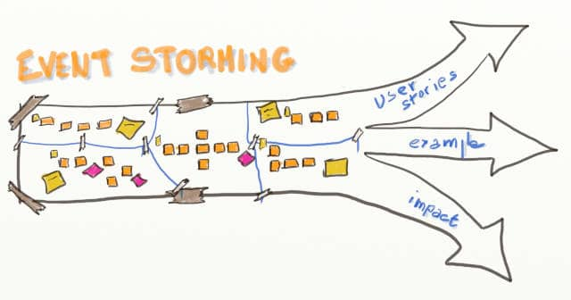

Drawing of an Event Storming design board that morphes in 3 arrows. It represents what can be done after a Big Picture Event Storming workshop.

### 3.9.1 Why would you want to run a Big Picture Event Storming

We first discussed Why would you want to run a Big-Picture event storming? We saw that **Event Storming is a middle path between Big Up-Front Design and 100% Emergent Design**. When facing a software architecture challenge, evaluate the following affirmations:

1. The architecture is not obvious
2. The people have the skills to tackle the challenge
3. Your progress has stalled despite following the usual successful methods

Event Storming is the way to go if all these affirmations are true!

### 3.9.2 Making the workshop successful



Picture of wooden steps in the tropical forest. Tackling complexity and running a long workshop such as Event Storming can be quite daunting from the outside. Step by Step facilitation instructions will make this smooth!

We then looked at how to make the event a success. **Preparation and facilitation are essential to successful Event Storming**.

* How to Prepare a Big-Picture Event Storming Workshop tells us what to prepare before it starts:
  + Active sponsorship
  + A clear scope
  + The right audience
  + An enticing invitation
  + A briefing speech.
* How to prepare the room for a Big-Picture Event Storming lists all the supplies for the workshop:
  + A visual agenda
  + A wall
  + A long strip of paper
  + Stickies
  + Sharpies
  + A small table
  + Food.
* What to say at the beginning of a Big-Picture Event Storming provides an example you can reuse.
* 5 steps are identified in Step by Step Guide to run your Big-Picture Event Storming:
  1. Generating Domain Events
  2. Sorting them
  3. Adding actors and external systems
  4. Storytelling
  5. Reverse Storytelling

Effective facilitation tips to engage participants in the workshop are proposed for each step.

### 3.9.3 Functional Architecture

**One of the main outputs of Big Picture Event Storming is to identify the Bounded Contexts** (Domain Driven Design for functional areas). **This Context Map** (Domain Driven Design for functional architecture) **is a cornerstone for optimizing technical investments and having teams collaborate effectively**.

* Improve collaboration with a Functional Architecture vision draft details how to add the Context Map to the design. This post also explains how this has a tremendous impact on overall collaboration.
* Decide to Build or Buy with Big-Picture Event Storming explains that **not all bounded contexts have the same value**. It also presents facilitation steps to make sound technical investment decisions. For example: “Should we build or buy part X of the system?”.

### 3.9.4 Dealing with Legacy Code

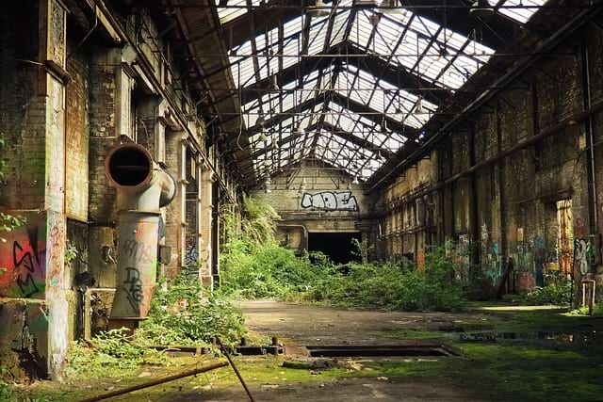

Photo of an abandonned factory, that is tagged and getting invaded by vegetation. This is a pretty vivid representation of some legacy code.

In Read this before applying Big Picture Event Storming to Legacy Systems, we advise against Event Storming your legacy. **Legacy systems usually don’t map to the domain and do not yield to the exercise**. Instead, Event Storm your vision with these three tips in mind:

* A longer brief is needed to convey some extra background associated with the Legacy System
* Acknowledge and visualize developers’ stress generated by the gap between the unveiling vision and the existing legacy systems.
* You will need to adapt the schedule even more than usual as the legacy system will surprise you with unexpected challenges.

### 3.9.5 Further Steps

At the end of Event Storming, you have all the problems and domain knowledge fresh in everyone’s mind. It’s a unique opportunity to tackle mind-numbing complex issues. Here are some pointers for follow-up activities:

* [Should you organize your teams along features or components?](https://philippe.bourgau.net/feature-teams-vs-component-teams-decide-with-event-storming-and-ddd/)
* [Should you rewrite or refactor a bounded context?](https://philippe.bourgau.net/rewrite-vs-refactor-get-insights-from-event-storming-and-ddd/)
* [How do you protect and invest in your crown jewels?](https://philippe.bourgau.net/focus-on-core-domain-with-relationships-from-ddd-and-event-storming/) Explicit the relationships between your contexts to ensure the core domain keeps priority.
* [Avoid big end-of-project performance failures by early prototyping your (micro)services and Non-Functional Requirements](https://philippe.bourgau.net/using-event-storming-and-ddd-to-prototype-microservices-and-nfrs-1/).
* [Decide what to ship early!](https://philippe.bourgau.net/how-to-fight-priority-paralysis-with-event-storming-and-ddd/)
* [Ship early while moving towards your vision by leveraging refactoring skills](https://philippe.bourgau.net/how-to-use-event-storming-and-ddd-for-evolutionary-architecture/)



Photo of a woman standing at the top of a mountain, watching over a cliff at the mountains on the other side of the valley. Like this hiker, as participants reach the end of the Big Picture Event Storming, a whole new world of possibilities open to them!

There are also other workshops that you can run after Big Picture Event Storming:

* Discover how to collaboratively plan your software delivery to maximize its impact with [Impact Mapping](https://www.impactmapping.org/)
* Organize your delivery with [User Story Mapping](https://jpattonassociates.com/story-mapping/)
* Map your ideal team organization with [Teams Topologies](https://teamtopologies.com/) mapping
* Get a 360 degrees view of a bounded context with the [Bounded Context Canvas](https://medium.com/nick-tune-tech-strategy-blog/bounded-context-canvas-v2-simplifications-and-additions-229ed35f825f)
* Apply finer grain Domain-Driven Design on a core context with Design-Level Event Storming

### 3.9.6 Design-Level Event Storming

Here you are: you’ve drawn your context map and identified your core contexts. How do you maximize and secure your technical investment in these? It turns out that this is what Domain Driven Design was created for! Guess what: Event Storming has more to offer! Let’s see how to use Design-Level Event Storming to move one step closer to code in a core context. Read on!

# 4 Design Level Event Storming

## 4.1 Why would you do a Design Level Event Storming?

*Design Level Event Storming is a workshop to design the core of your system. What is it exactly? What are its outcomes? Where should you use it?*

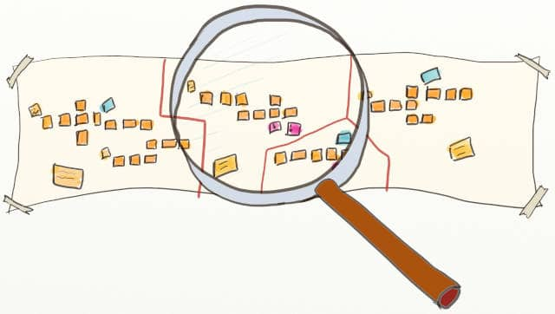

Drawing of a DDD Event Storming board with a loop on one Bounded Context. Design Level Event Storming is about diving in the details of a core Bounded Context

Imagine you are starting a new product with your team. You had been struggling for a while about how to start.

* What should the high-level design be?
* What should we focus on first?
* What are the main risks?

All these questions remained unanswered until you heard about [Event Storming](https://www.eventstorming.com/)!

You decided to try Big Picture Event Storming. As a result, you drafted a functional architecture vision in one or two (intense) days! That’s more progress than you had made in weeks. Also, you managed to identify the functional areas in your domain. Then, you have highlighted the topics you’ll focus on to create your competitive advantage. These are your core bounded contexts.

Everyone on the team now understands where to focus. So, finally, it looks like the teams are ready to start!

💡 Wait, how do you get from the Big Picture Event Storming to designing and writing software?



Photo of an athlete in his starting blocks. Big-Picture and Design-Level Event Storming workshop are really about making the best start possible when building systems with Domain-Driven Design (DDD)

Event Storming has more to offer! We can zoom in with Design-Level Event Storming. We’ll look into the following questions:

* What problems does Design Level Event Storming solve?
* What are the outcomes of Design Level Event Storming?
* How does Design Level Event Storming work?
* On which parts of your system should you run a Design Level Event Storming?

### 4.1.1 What problems does Design Level Event Storming solve?

It’s a way to create a collaborative design with a whole software team to solve problems like:

* **How can we make good enough design decisions in 1 day instead of months?**
* **How can we be sure that everybody on the team understands our target design and pulls in that direction?**
* **How can we leverage the perspective of everyone and not just of a few experts?**

### 4.1.2 What are the outcomes of Design Level Event Storming?

The Design Level flavor of Event Storming lets you **dive into the details of a**[**bounded context**](https://martinfowler.com/bliki/BoundedContext.html). Its primary outcome is a good enough and shared design vision. Developers who attend the workshop should be able to start coding straight away.

📝 Big Picture Event Storming was about exploring [strategic and large-scale Domain Driven Design](https://thedomaindrivendesign.io/what-is-strategic-design/); Design-Level Event Storming is about [small-scale DDD](https://thedomaindrivendesign.io/what-is-tactical-design/) inside a domain.

During your Design Level Event Storming, you will:

* Detail the information contained in domain events
* Draft what the screens should display
* **Identify potential services** in your architecture (aka Aggregates in DDD Vocabulary) and what they should do
* Identify the need for interaction with external systems, which is the starting point for API design
* Pinpoint critical issues: [the most pressing problems and the primary domain concept definitions](http://philippe.bourgau.net/5-views-to-capture-the-outputs-of-an-event-storming-workshop/).
* Get the whole team to collaborate and design together
* **Align all the team towards a shared vision**, which saves tremendous time as developers all nudge the code in the same direction!
* Set the team on a sustainable pace by finding the perfect balance between Big Up-Front Design and Emerging Design!

📝 A **DDD Aggregate** is a small-scale programming pattern that recommends creating and destroying objects as grapes with a root.

### 4.1.3 How does Design Level Event Storming work?

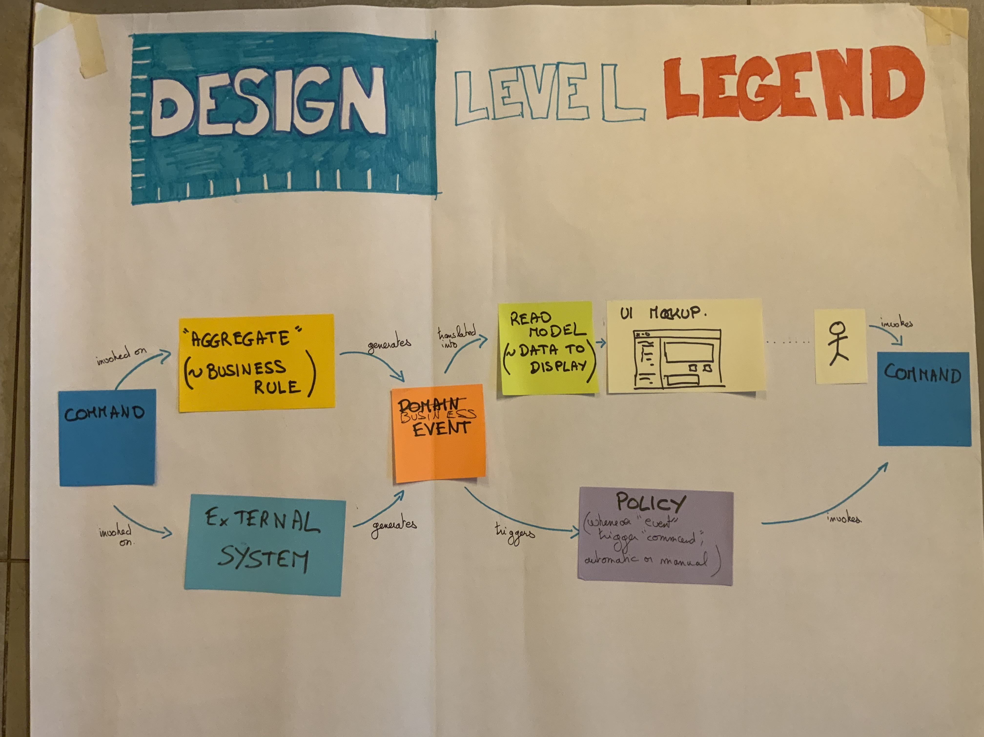

Poster that explains how the different design elements of Design Level Event Storming interact with each other. “The picture that explains everything,” as defined by Alberto Brandolini.

Source: [Introducing Event Storming](https://leanpub.com/introducing_eventstorming), [Alberto Brandolini](https://twitter.com/ziobrando).

**Similarly to Big Picture Event Storming, the Design Level flavor is a time compressor!** It relies on intense and high-bandwidth collaboration. It follows the same dynamic as Big Picture Event Storming, though it’s a bit more detailed and technical.

### 4.1.4 On which parts of your system should you run a Design Level Event Storming?

Design Level Event Storming is a zoom-in, yet not all system parts require that much attention! Here are three pre-requisites to know on which parts of your system you should run a Design Level Event Storming:

* First, you identified it as business-strategic and a business differentiator.
* It’s a real functional area about which developers and non-developers can talk and understand each other. It’s not a technical brick that only developers can understand
* It contains complicated domain logic that [deserves Domain Driven Design](https://stackoverflow.com/questions/27638513/when-we-shouldnt-use-domain-driven-design-approach%60) (ex: finance. If there are books written on this domain, it’s a clue!)

These checks should look familiar if you ran a Big Picture Event Storming before! This is because they correspond to your core bounded contexts. **Design Level Event Storming is a natural continuation of Big Picture Event Storming.**

If you haven’t run a Big Picture Event Storming before, as long as the previous checks are ok, Design Level Event Storming will work! You’ll have to start with a fast “mini big picture event storming” on your scope. That’s also a way to “redo” a quick Design Level Event Storming to adjust as you progress.

Finally, Design Level Event Storming is particularly well suited to design microservice or [Event-Sourcing](https://martinfowler.com/eaaDev/EventSourcing.html) systems. If you plan to architect your system with these, that’s yet another incentive to use Design Level Event Storming.

### 4.1.5 Conclusion

If you have identified a functional area of your system that:

* Is **A key business differentiator**
* Contains **complicated domain logic** that deserves Domain Driven Design

Then run a Design Level Event Storming with the whole team which will build it! In a few hours:

* **You’ll make complex design decisions that would have taken months**
* **You’ll get a head-start on design**
* **Everybody will be moving in the same direction**

We’ll now explain how to facilitate your first Design Level Event Storming!

## 4.2 How to explain Design Level Event Storming to your mother

*Design Level Event Storming relies on advanced* [*Domain Driven Design*](https://en.wikipedia.org/wiki/Domain-driven_design) *vocabulary. Here is how to make things simple for your participants.*

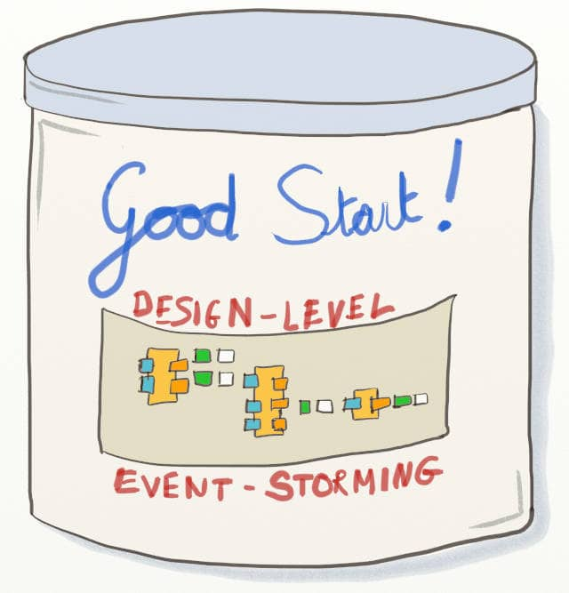

Drawing of a can of ‘Good Start’ about Design-Level Event Storming

I have a hard time remembering all these words like “Policies” and “Aggregates” (a participant)

Sorry, Aggregates can only receive commands. They cannot emit any! (the facilitator)

I’m sorry, I’ve lost track here. I’m kind of waiting for others to come up with something. (a participant)

Design Level Event Storming is finer grain and more technical than Big Picture. It also relies on Domain Driven Design vocabulary to model technical concepts. The DDD jargon is precise but also challenging to grasp at first!

📝 [The first rule of DDD](https://philippe.bourgau.net/first-rule-of-ddd-is-lets-not-talk-about-ddd/): “Don’t speak of DDD!”

How can we provide essential DDD fluency to participants as we start the workshop? In a few minutes?

### 4.2.1 “The picture that explains everything”

We briefly mentioned the “Picture that explains everything” in the previous chapter. [Alberto Brandolini](https://twitter.com/ziobrando) [introduced this picture](https://leanpub.com/introducing_eventstorming) to explain how to organize stickies.



Poster that explains how the different design elements of Design Level Event Storming interact with each other. “The picture that explains everything,” as defined by Alberto Brandolini.

Source: [Introducing Event Storming](https://leanpub.com/introducing_eventstorming), [Alberto Brandolini](https://twitter.com/ziobrando).

We find the name of this picture a bit misleading! From the puzzled looks of people, we can guarantee that this picture needs explaining!

Before you start the workshop, display the picture, and ask people what they understand. Some people might be able to explain parts of it to others. Finally, read the following explanation to ensure everybody starts from the same place.

### 4.2.2 A speech to present Design Level Event Storming

Alberto Brandolin, the inventor of Event Storming, calls this “The Picture That Explains Everything.” It shows how DDD event-based systems work. In addition, it features all the possible arrangements of stickies we can use in the workshop.

The goal of this Event Storming is to design our system with these arrangements.

This poster explains how Domain Events cascade during the system’s life.

A **Domain Event** is simply something that happens in your system.

ℹ️ Participants must understand what domain events are. Refer to What to say at the beginning of a Big Picture Event Storming for more explanations.

Let’s start from the left of the picture. Commands are sent either to external systems or to our aggregates.

A **Command** is an order sent to the system, often by a human, for example, when he clicks something. But it can also come from a policy, and we’ll see that later.

**External Systems** are any other computer systems outside your workshop’s scope.

ℹ️ Look at the Step-by-Step Guide to run your Big Picture Event Storming for more details.

**Aggregates** is the code you will write to handle our critical business rules. An “Aggregate” aggregates the business rules related to a particular business concept. That might sound a bit blurry, but trust me, that’s all you need to know to get started! Take it easy. You will understand Aggregates better as we go through the steps of the workshops.

Both Commands and Aggregates then raise a domain Event.

Some events will “automatically” trigger another command. We materialize this link through policies.

A **Policy** is an automation rule. A rule of thumb is that it follows the pattern “Whenever <domain event>, Then trigger <command>.” Policies can be implemented by code or by a human operator.

We use lilac stickies for policies, like the one at the bottom right.

Other events notify Actors.

An **Actor** is a human that interacts with the system.

ℹ️ You can find more details about actors in Step by Step Guide to run your Big Picture Event Storming.

Actors should be able to react to events by sending new commands. To do so, they’ll need to see the correct information. That’s the green read-model sticky.

A **Read Model** is simply the list of all the information to display in the User Interface.

We’ll also have to display this information in a good UI. We can mock-up this UI in the white sticky.

A **UI mock-up** sticky is simply a drawing of what the user would see.

This brings us to the right of the picture. It ends as it started, with a command. That’s how we can chain this picture to model the whole system.

By the end of the workshop, the board should consist of many repetitions of this pattern.

From now on, we should make everything explicit. Everything we say should appear on the board.

Leave the poster on the wall so participants can refer to it during the workshop. Adding a legend with the definitions is also a good idea.

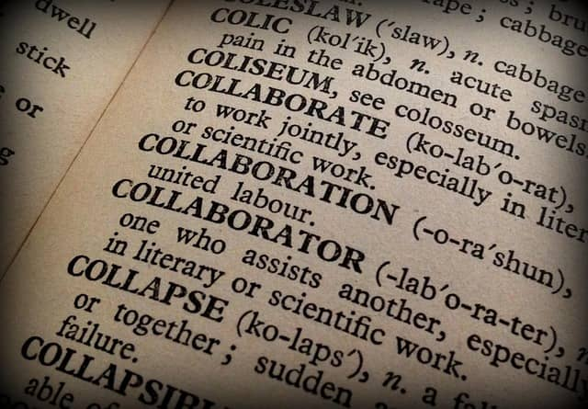

A photo of a page of a dictionary. Domain Driven Design comes with quite a lot of vocabulary, and the learning curve can be steep. In Design Level Event Storming, we can define just the bare minimum to get going.

### 4.2.3 You’re ready!

That’s all the definitions you need! Let’s dive in a detailed agenda for the whole Design Level Event Storming.

## 4.3 The Best Agenda For Design-Level Event Storming

*Use Design-Level Event Storming to identify Aggregates, UX mockups, and other design elements. Just follow this agenda through your first facilitation!*

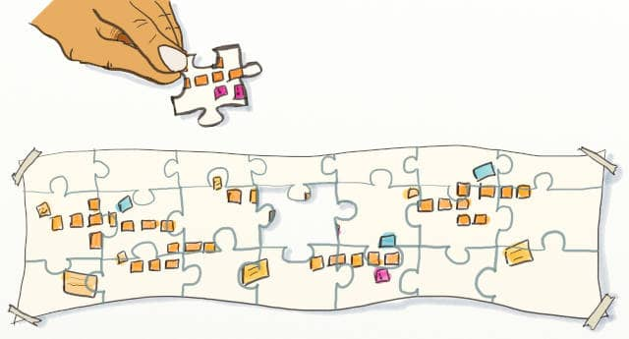

Drawing of an event storming board jigsaw with one piece left to place. This represents the final step to finishing a Design-Level Event Storming

So, here you are! You have identified a business-critical bounded context. (Remember, bounded contexts are just functional areas) It is the perfect occasion to use Design Level Event Storming!

Let’s see how to get started!

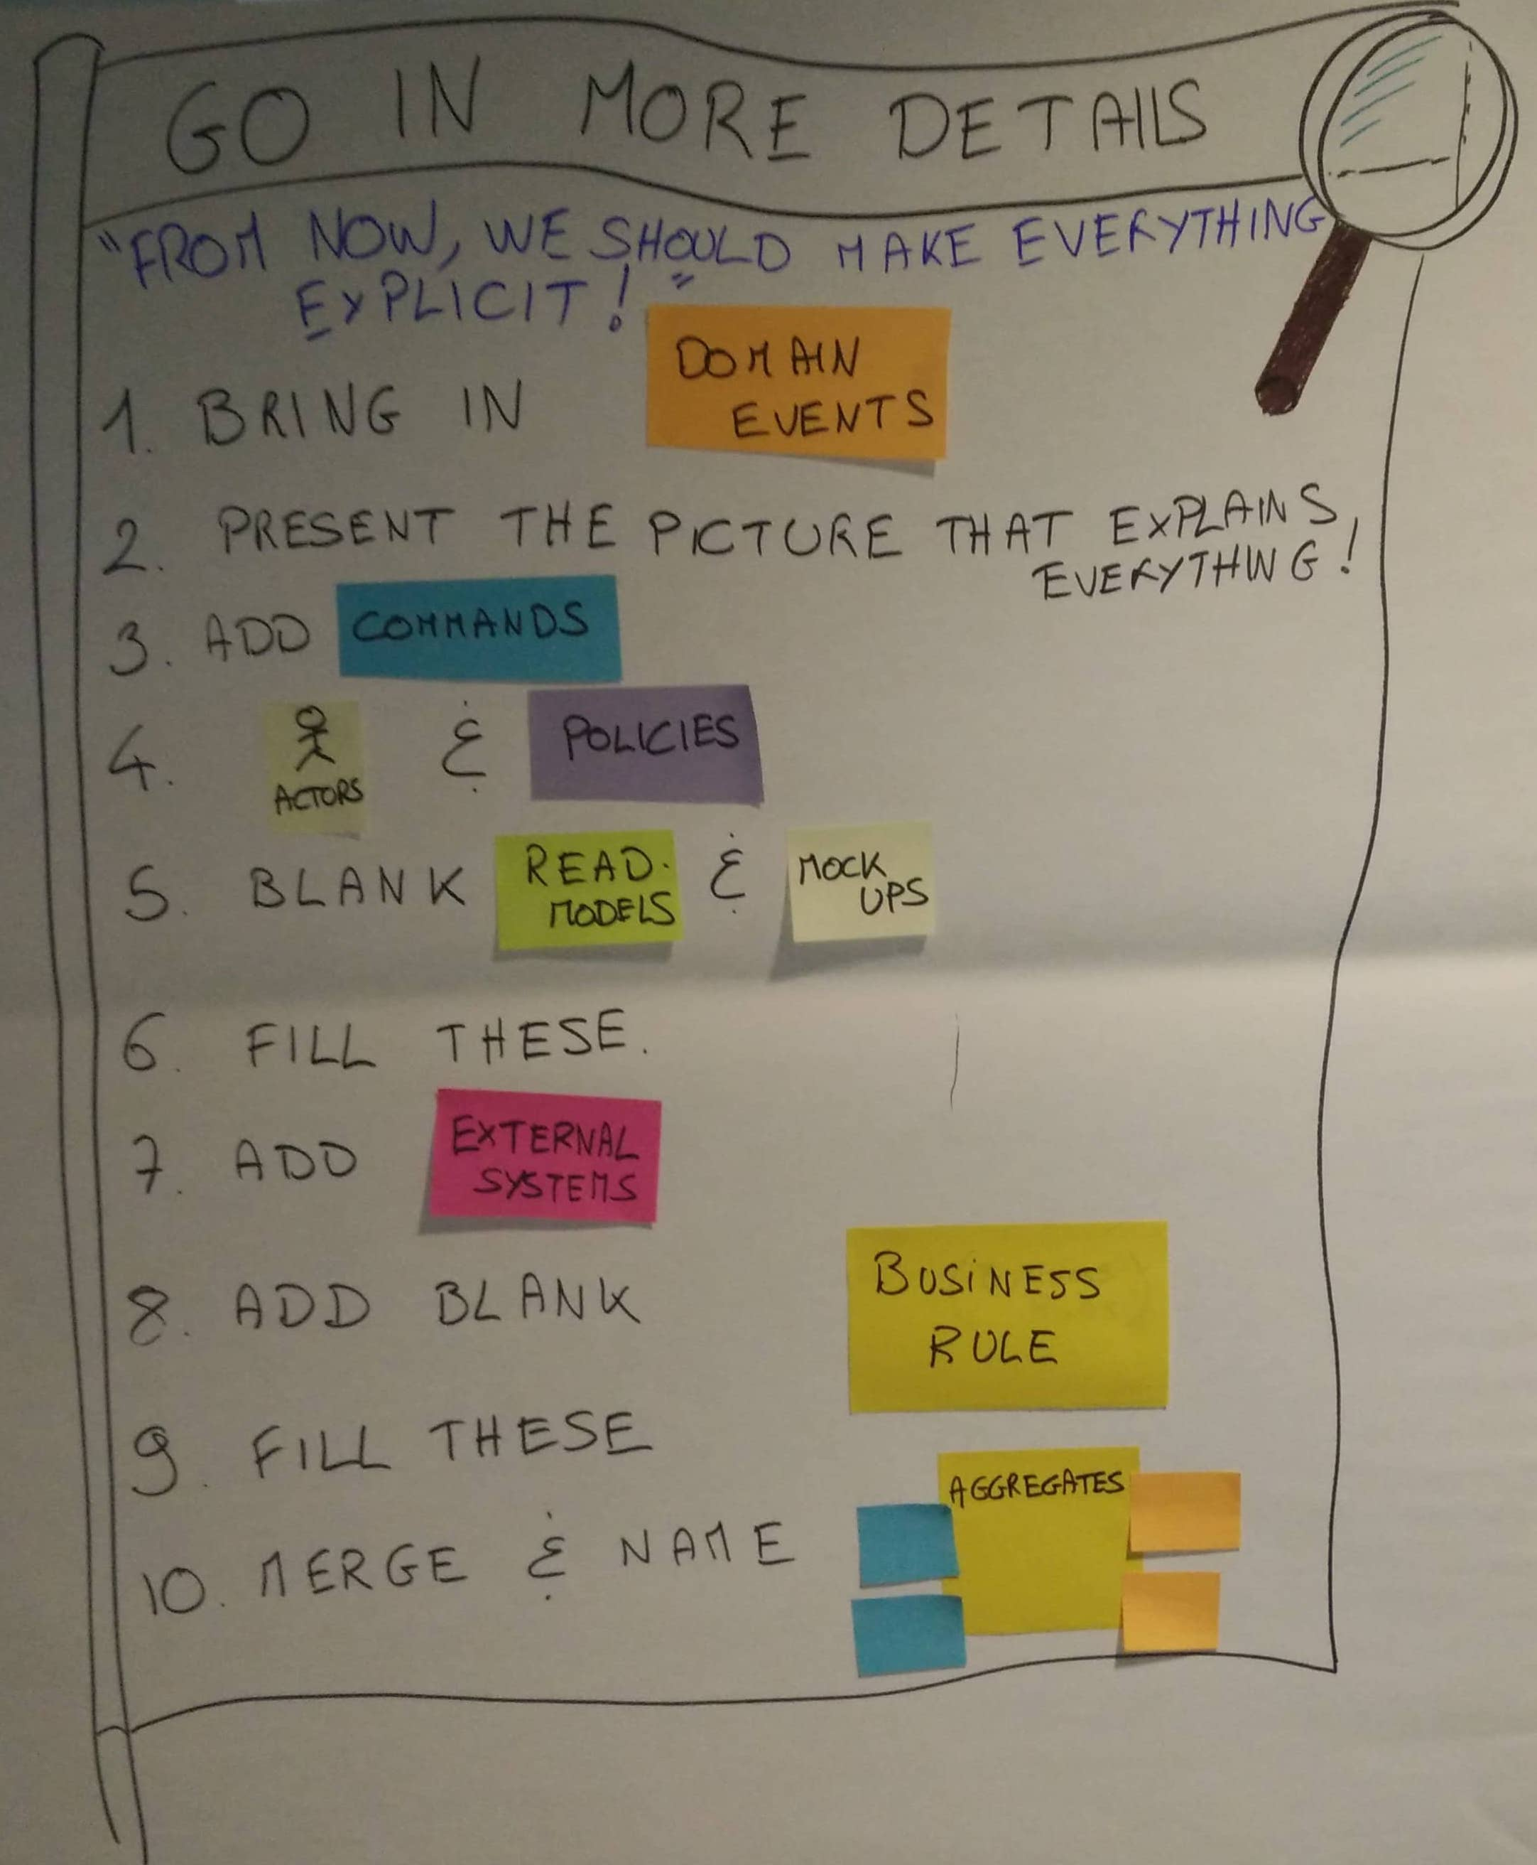

Poster presenting the agenda of a Design-Level Event Storming. The phases are: 1 Bring in Domain Events, 2 Present the picture that explains everything, 3 Add commands, 4 Actors and policies, 5 blank Read Models and Mock Ups, 6 Fill these, 7 Add External Systems, 8 Add blank business rules, 9 fill these, 10 Merge and name Aggregates

Big Picture is about exploring. Design-Level is about designing and building.

Here is a detailed and step-by-step agenda that you can follow to facilitate your Design Level Event Storming. You’ll see that many steps in the workshop are almost mechanical. So, follow the guide, and everything will go well!

1. The target design
2. Domain Events
3. Commands)
4. Actors and Policies
5. Blank read-models and UX mock-ups
6. Read models and UX mock-ups
7. External Systems
8. Blank Business Rules
9. Business Rules
10. Aggregates of Business Rules
11. Aggregates Names

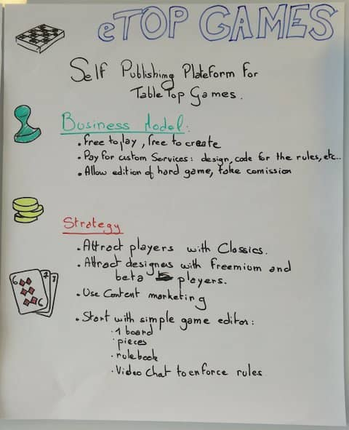

A poster presenting ‘eTop-Games’, a self-publishing table-top games startup idea. Business model: free, pay for custom services (design, rules hardcoding…), can sell physical printouts of games. Strategy: attract players with classics, attract designers with freemium and beta players, use content marketing, start with a simple game editor (1 board, pieces, a rulebook, a video chat, social rules enforcement)

Let's take an example to illustrate how to run the workshop. Imagine you are in a software company that builds a self-publish board games website.

The website also lets people play their games online. In the examples below, we will be running the Design-Level Event Storming on this "live game" bounded context. It is one of many functional areas of the whole system.

### 4.3.1 The target design



Poster that explains how stickies chain together on a Design-Level Event Storming board. “The picture that explains everything,” as defined by Alberto Brandolini.

Source: [Introducing Event Storming](https://leanpub.com/introducing_eventstorming), [Alberto Brandolini](https://twitter.com/ziobrando).

Before you start, you’ll need to ensure that everyone understands what Design Level Event Storming is about. Refer to our previous chapter, How to explain Design Level Event Storming to your mother, for detailed instructions to present the workshop and all the vocabulary.

The workshop will make the above pattern of stickies emerge step by step.

### 4.3.2 Domain Events

The first thing you’ll need in a Design-Level Event Storming is [domain events](https://martinfowler.com/eaaDev/DomainEvent.html)!

If you are running this workshop after a Big Picture Event Storming, copy the events from the part of the system you are focusing on to another blank design board. As usual, we are using orange stickies for events.

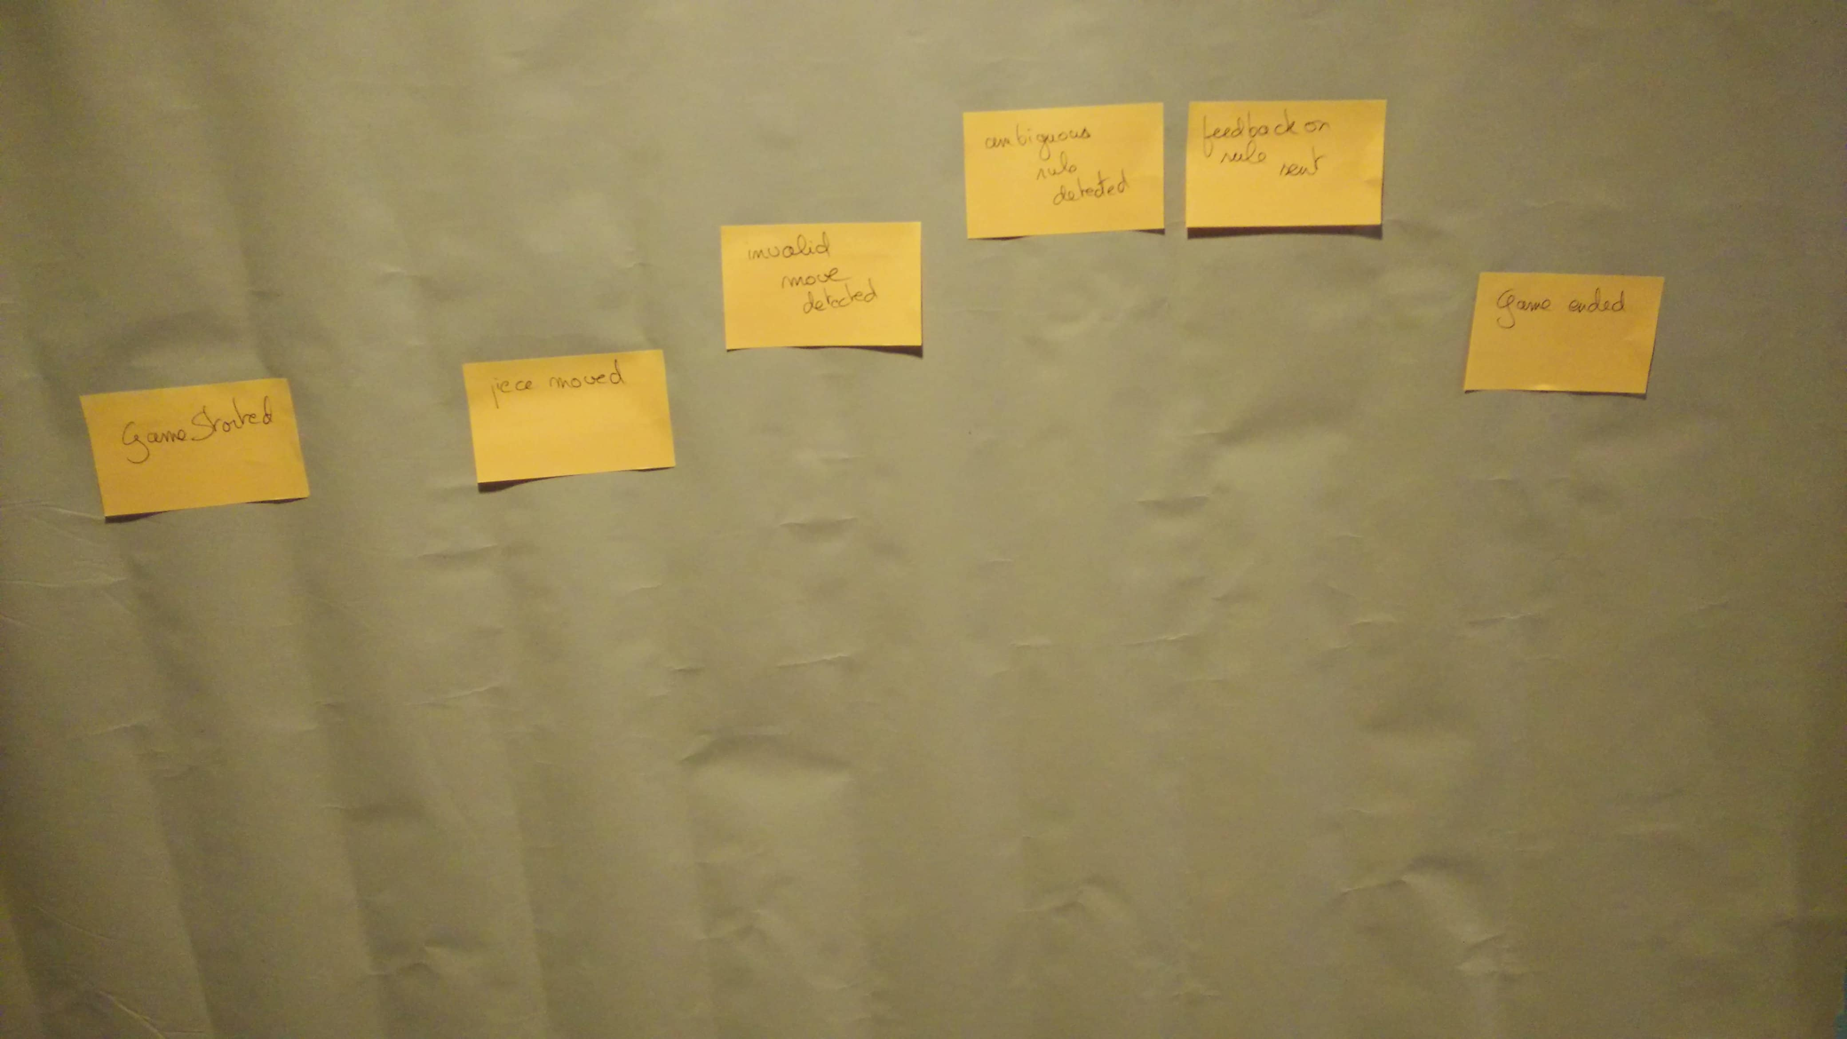

Photo of “live game” sub domain events. We can see events ‘Game started’, ‘Piece moved’, ‘Invalid move detected’, ‘Ambiguous rule detected’, ‘Feedback on rule sent’, ‘Game ended’

If starting from scratch, you will still need to generate events. You can run the first steps of the Big Picture Event Storming on your limited scope:

1. Events Generation
2. Events Sorting
3. Actors and External Systems
4. Storytelling

Check A detailed agenda of Event Storming to learn how to run these steps in detail.

### 4.3.3 Commands

The next step is to prefix every [domain event](https://martinfowler.com/eaaDev/DomainEvent.html) with a blue [command](https://en.wikipedia.org/wiki/Command_pattern) sticky. This step is straightforward: if you have an event called “Game Started”, prefix it with the command “Start Game”. Sometimes, the command names are a bit different, but you should manage to figure this out.

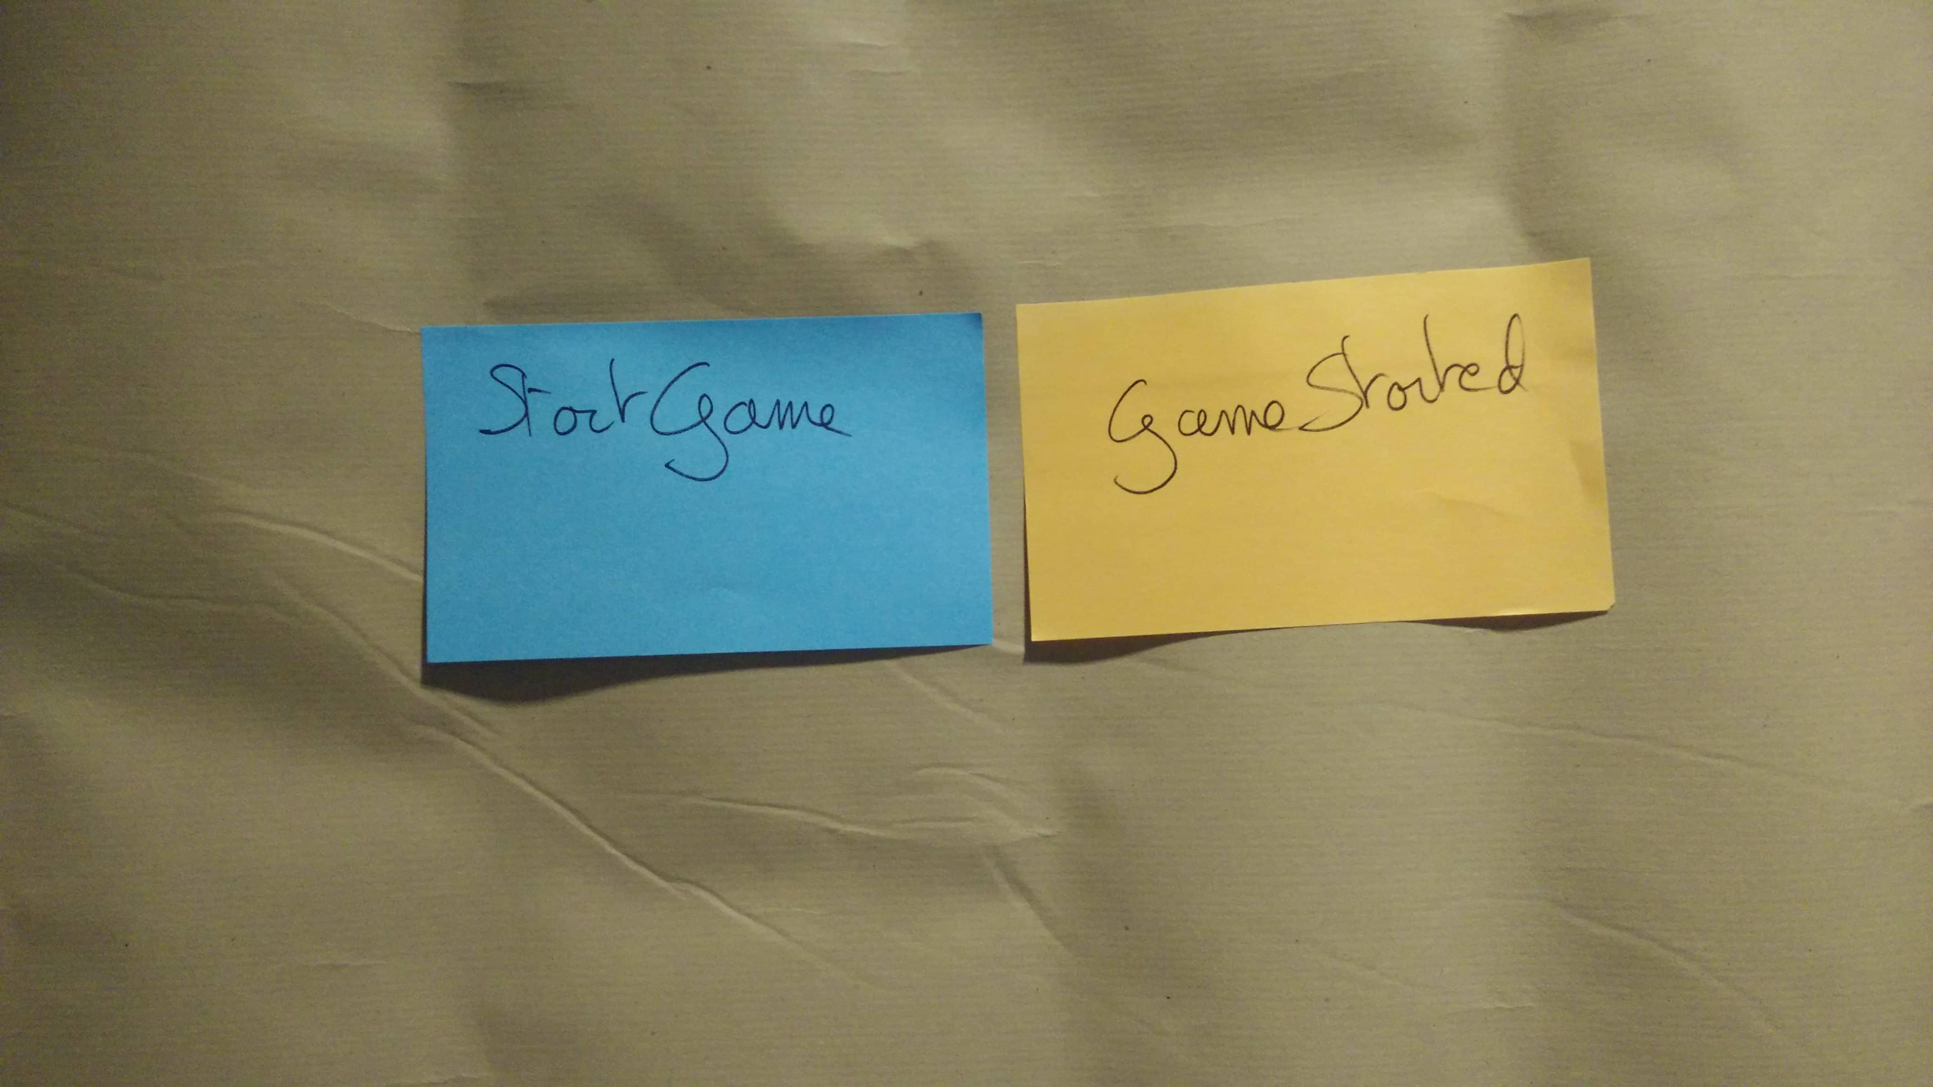

Photo of the ‘Start Game’ command blue sticky, stuck just to the left of the ‘Game Started’ domain event

### 4.3.4 Actors or policies

Commands can either be sent by a human (an actor) or automatically by a policy.

Go through all the commands and prefix them with an actor or a policy.

If you have been through a Big Picture Event Storming, you should have identified the actors, so copy them.

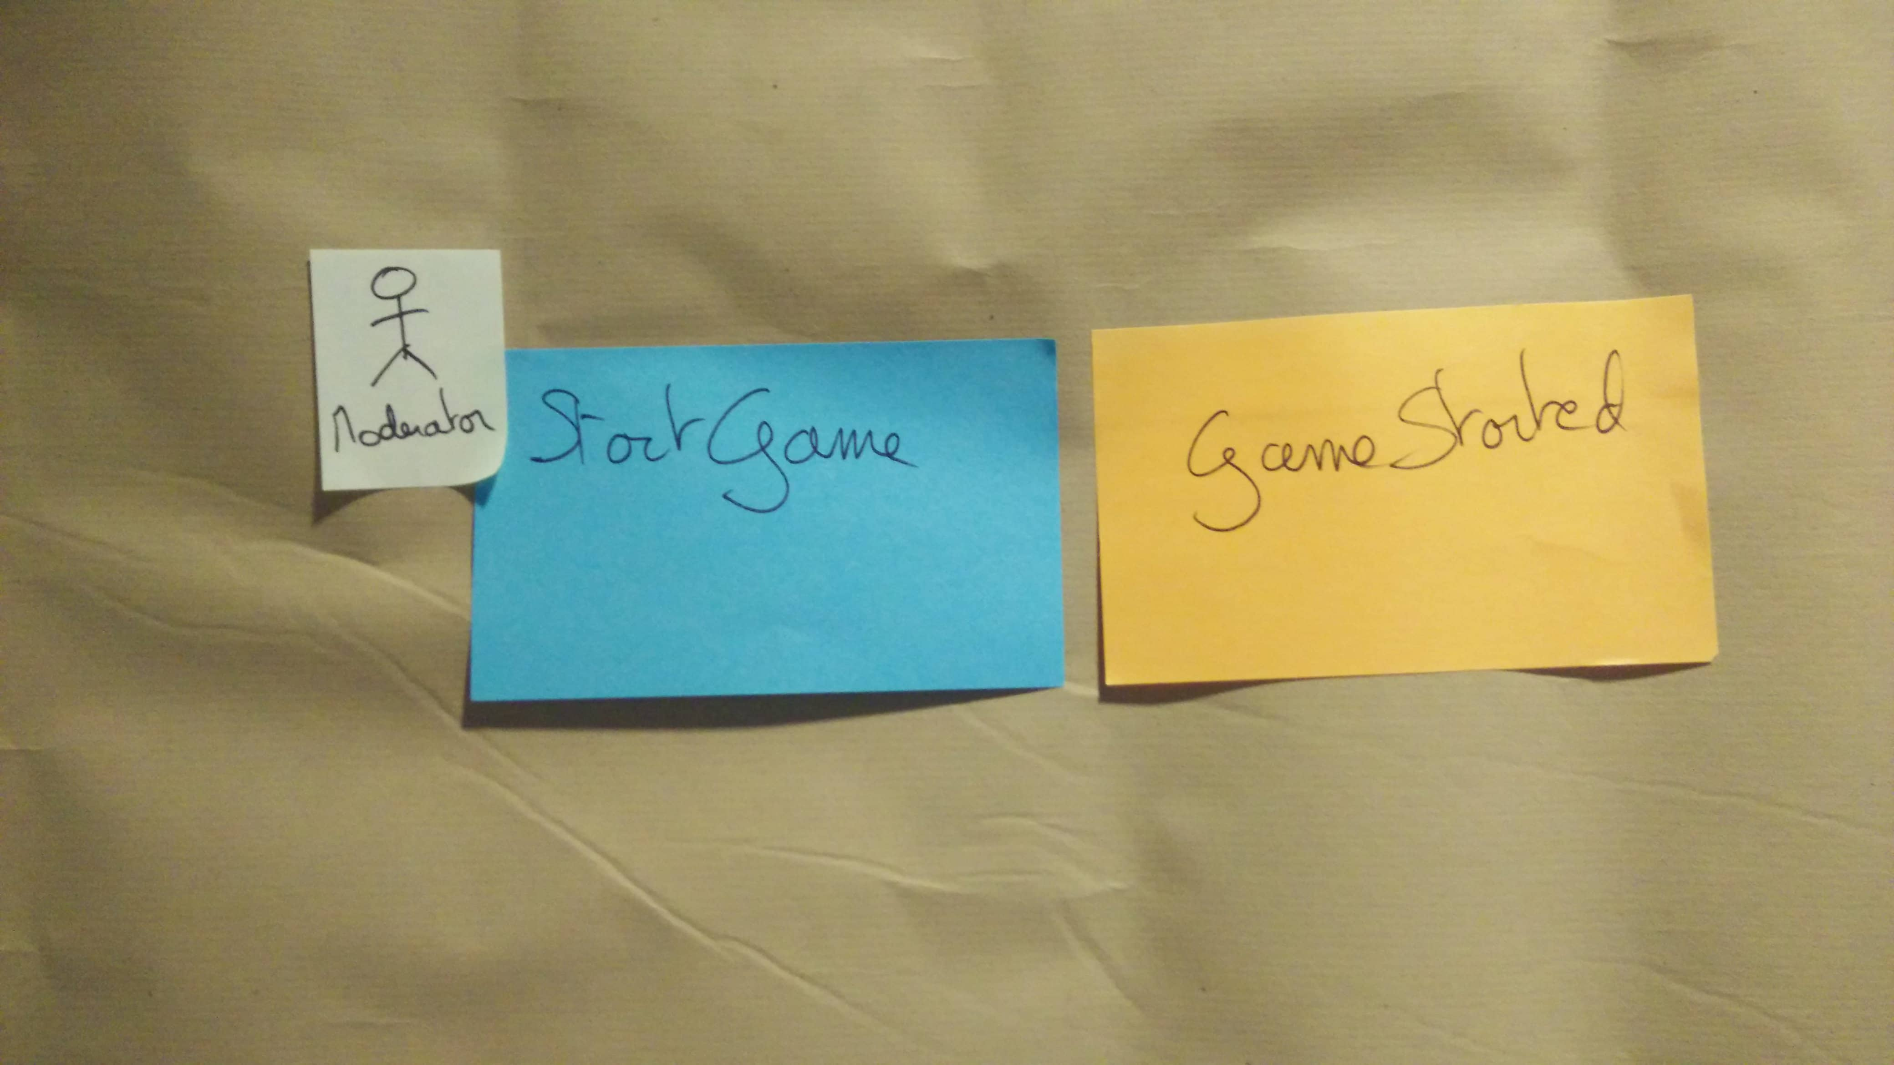

Photo of the ‘Moderator’ actor small and pale sticky, stuck just to the left of the ‘Start Game’ command

Actors should have a title, and policies should follow the form “Whenever Event X, then Command Y.”

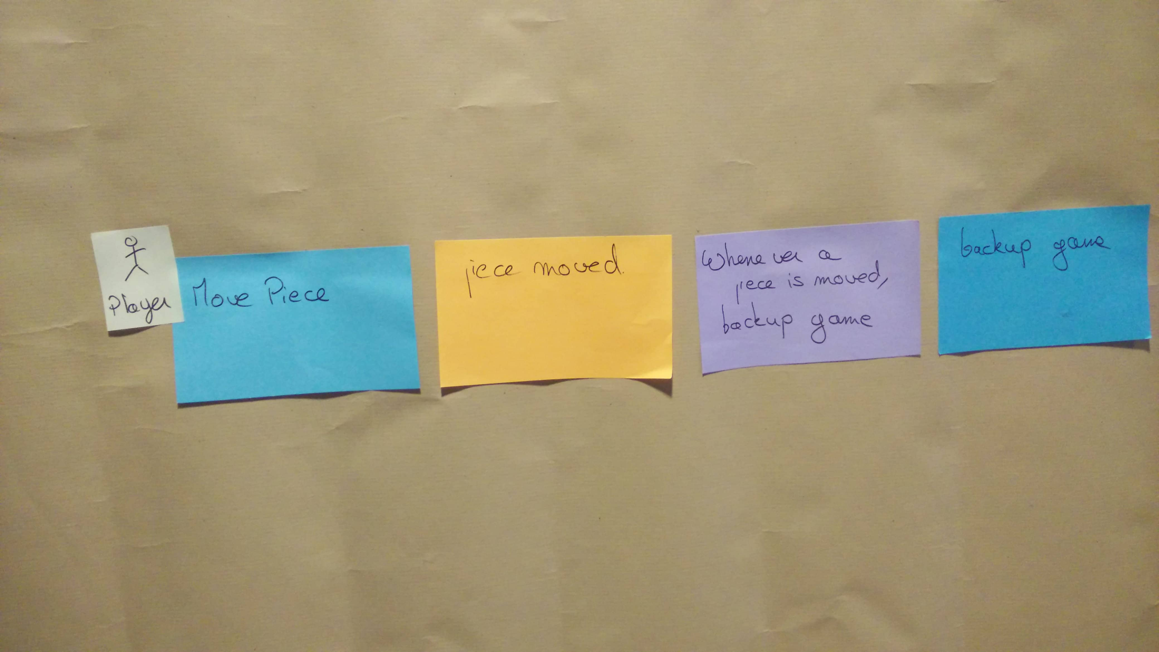

Photo of a policy ‘Whenever a piece is moved, backup game’ on a lilac sticky between the ‘Piece moved’ domain event and the ‘Backup Game’ command

(Note: Policies are sometimes manually automated: a human does it. In this case, it’s simpler to keep modeling this as a policy rather than introducing a ‘dumb’ actor)

### 4.3.5 Blank stickies for what the actors will see

Actors need information before they can send a command. So, again, we’ll use stickies for that!

Again, this step is a mechanic: add blank green and white stickies between domain events and actors!

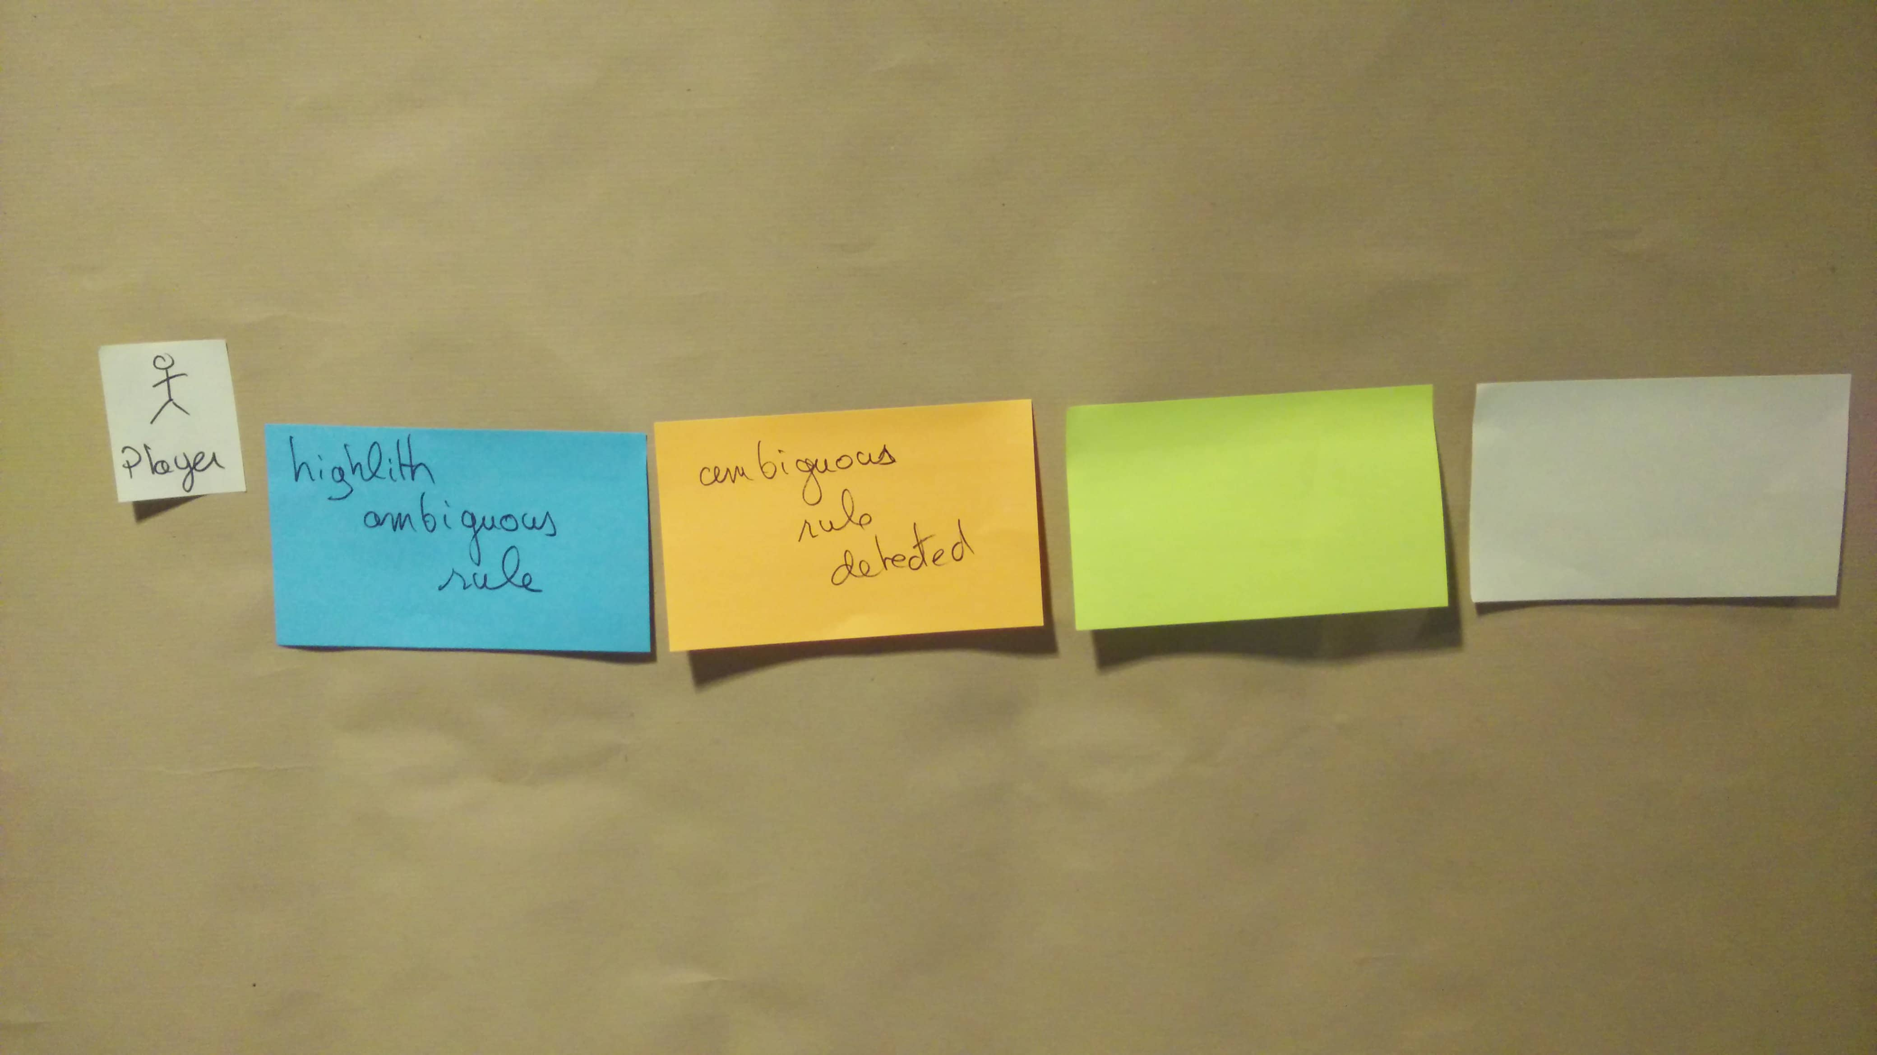

Photo of blank Read-Model green sticky and blank UI Mock-up white sticky at the right of the ‘Ambiguous Rule Detected’ domain event

### 4.3.6 Read models and UX mock-ups

Let’s list the information the actors need to send their commands.

📝 Design-Level Event Storming is the perfect workshop to discuss the UX of domain events

1. First, write down the data you want to display on the green sticky. This is a Read-Model.
2. Second, on the white sticky, sketch the user interface that will display the data on the screen. This is a UX mock-up.

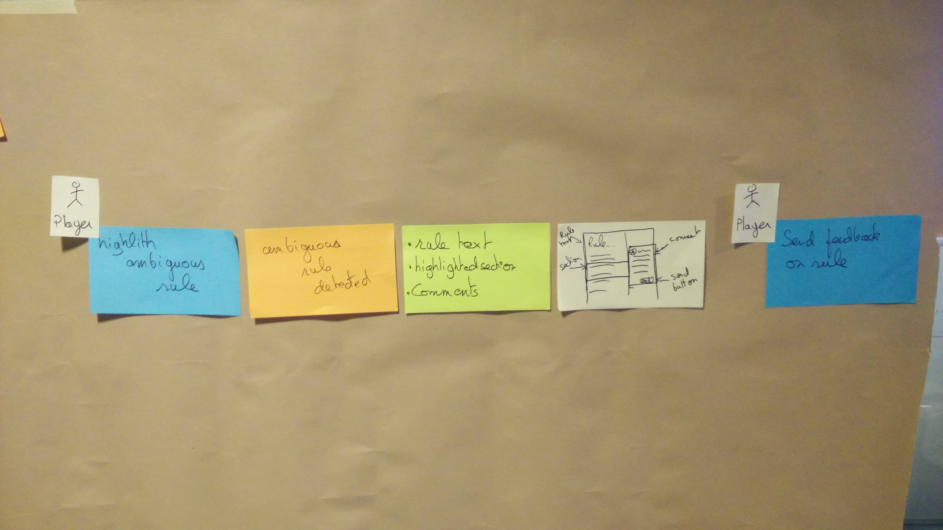

Photo of a Read-Model containing {Rule text, Highlighted section and Comments} and a UI Mock-up sketch at the right of the ‘Ambiguous Rule Detected’ domain event, between the ‘Ambiguous Rule Detected’ domain event to the left and the ‘Send feedback on rule’ command to the right

### 4.3.7 External systems

You’ve been looking at what happens ‘after’ a domain event. Let’s dive into what happens between a command and an Event.

The “picture that explains everything” shows that external systems also raise domain events.

If you have done a Big Picture Event Storming before, you should have spotted a few external systems. Copy them to pink stickies and stick them between Commands and Events.

If you haven’t gone through a Big Picture Event Storming before, go through all commands and add pink stickies for external systems where it makes sense.

In the scope of a bounded context, other contexts become external systems too! Go through all the remaining commands. Add a pink sticky between the command and the event when they involve another context. Write the name of the other context on the pink sticky.

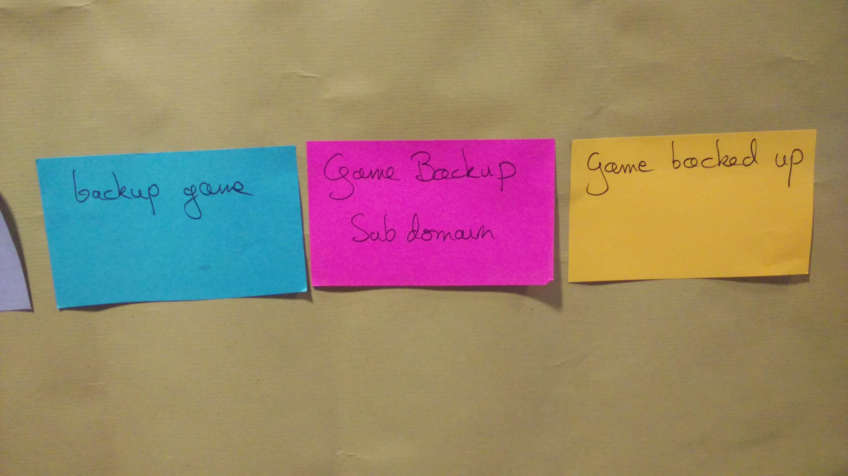

Photo of the ‘Game Backup Subdomain’ external system pink sticky between the ‘Backup game’ command to the left and the ‘Game backed up’ domain event to the right

### 4.3.8 Blank Business Rules

Here’s another mechanical step. If an external system did not raise an event, a business rule must have triggered it.

Go through all commands and events not linked by an external system. Add an empty yellow sticky there.

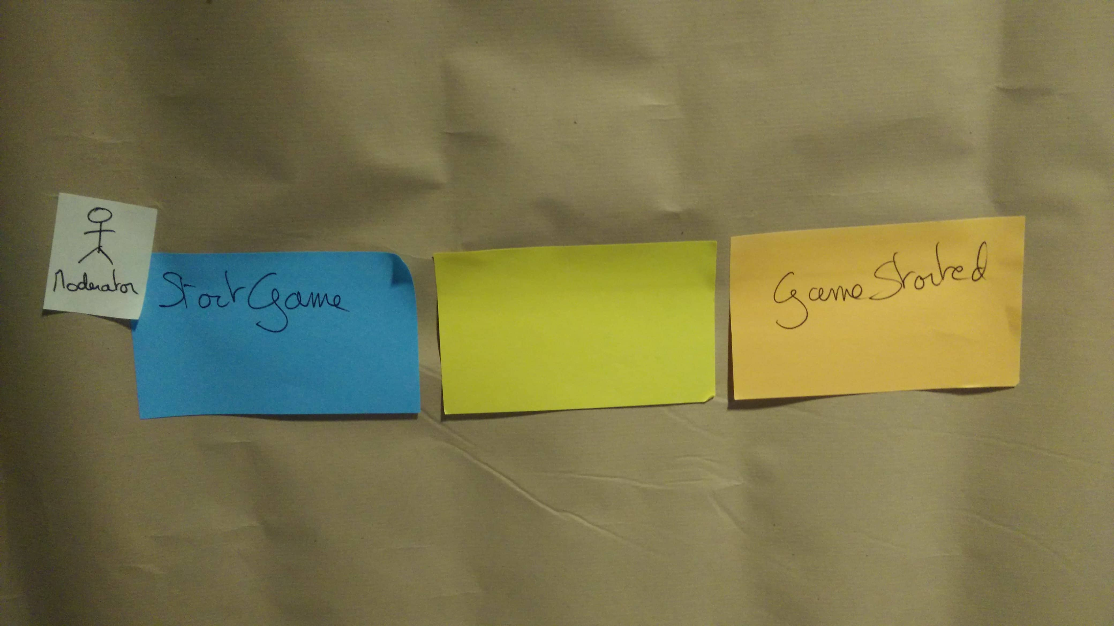

Photo of a blank Business-Rule yellow sticky between the ‘Start game’ command to the left and the ‘Game Started’ domain event to the right

### 4.3.9 Business Rules

📝 Discussing Business Rules is the critical moment of Design-Level Event Storming

Ask participants to fill in these business rules with what happens during its execution:

* What is true before (preconditions).
* What is true after (postconditions).
* What remains true all along (invariants).
* Any additional information to clarify what the business rule does.

Some business rules are dead-simple, while others will trigger much discussion. This knowledge-sharing between domain experts and developers is invaluable.

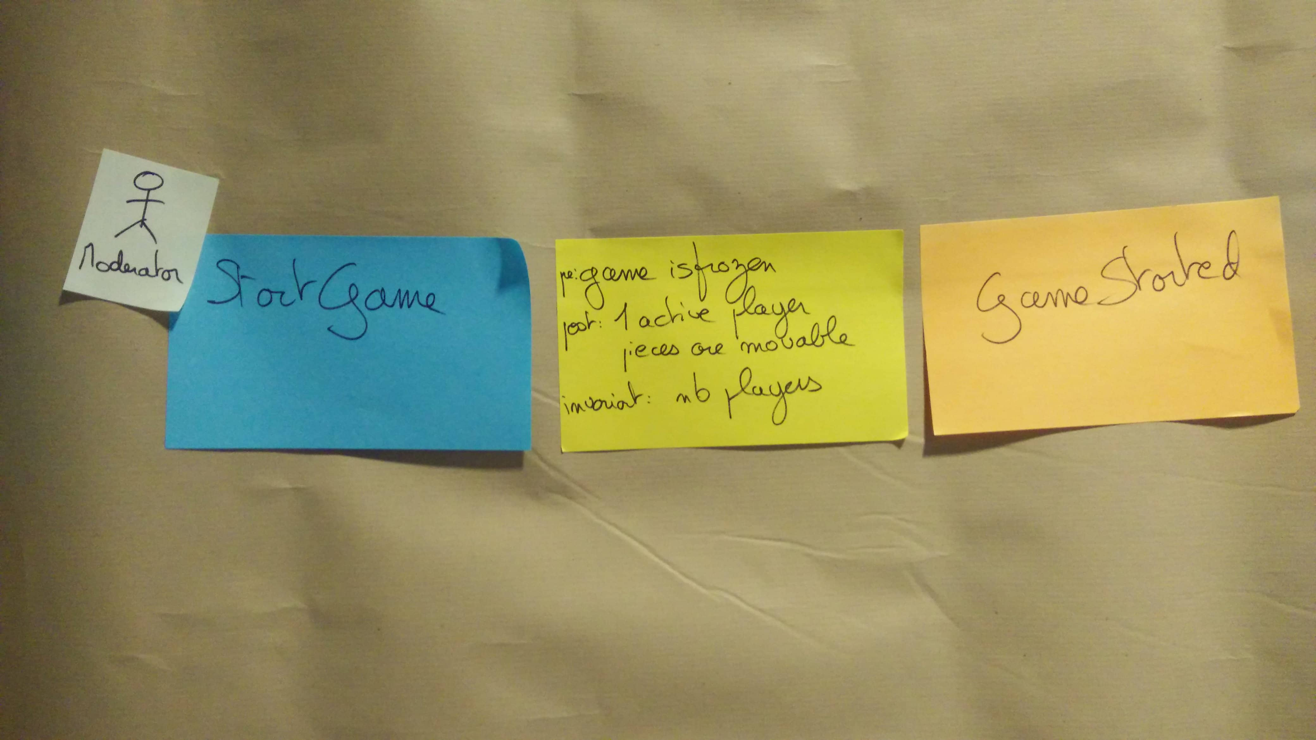

Photo of a Business-Rule containing {precondition: game is frozen, postcondition: 1 active player, postcondition: pieces are movable, invariant: number of players} between the ‘Start game’ command to the left and the ‘Game Started’ domain event to the right

📝 These conversations can be an occasion to use other practical conversation formats like [Example Mapping](https://cucumber.io/blog/bdd/example-mapping-introduction/)

### 4.3.10 Aggregates of Business Rules

Up to here, you’ve always kept the chronology in the design. Now, you will break this to get closer to code design!

When you spot two business rules that deal with similar data, move them on top of one another. Your board should now look like that:

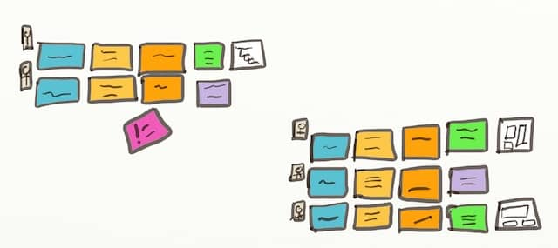

High level drawing of what a Design-Level Event Storming will look like once we group related business rules together

### 4.3.11 Aggregates Names

By aggregating business rules, you have formed Aggregates in the Domain-Driven-Design sense!

📝 Finding good names for Aggregates is the last thing to do in a Design-Level Event Storming

At this point, it should be easy to name your aggregates! So next, add an extra yellow sticky on top of the aggregates to give the group a name. For example, in the image below, the Aggregate’s name is “Game.” This is because it groups two business rules that deal with game workflow.

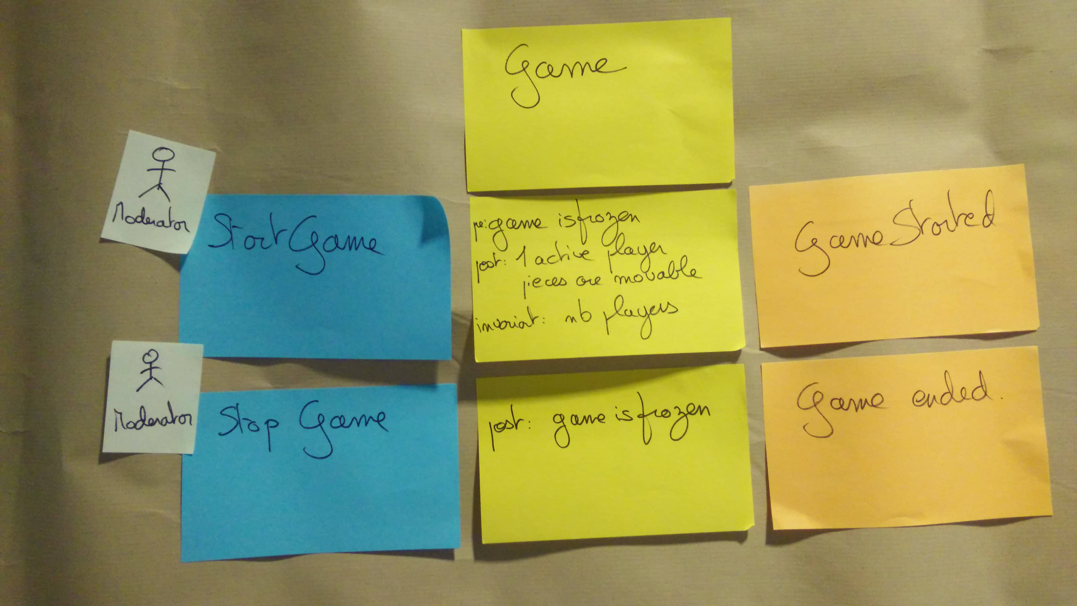

Photo of the ‘Game’ Aggregate materialized by a yellow sticky on top of the business rules stickies for ‘Start Game’ and ‘End Game’ commands

### 4.3.12 That’s all, folks!

You’ve reached the end of the workshop! As you’ve seen, Design-Level Event Storming is very structured yet leaves space for critical discussions.

To summarize, you started with the following:

* An important bounded context
* Some domain events in this context

And you ended up with:

* Aggregates and business rules
* Design mockups for user screens
* Automation policies
* A list of interaction points with actors and external systems
* And the most essential thing: shared knowledge and understanding between everyone involved



Photo of a mountain path where we can guess the sun will appear at the next turn. Design-Level Event Storming is a step by step workshop that leads to great outcome.

You’ve learned everything there is to know to facilitate your first Design Level Event Storming. If you have already run a Big Picture Event Storming, there is nothing to be afraid of here.

Send the invites, and get started!

## 4.4 Design Level Event Storming in 3 minutes

*In this part, we went deep into the technical details. Let’s take a step back from Design Level Event Storming!*

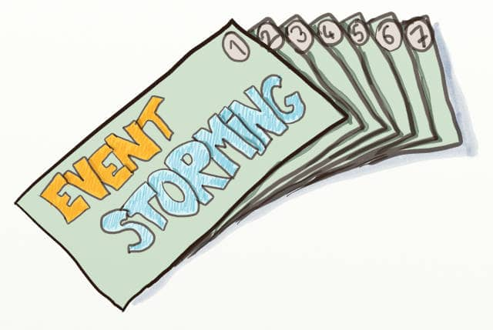

Drawing of a stack of 7 cards written Event Storming on the back. They represent the 7 tips on Design-Level Event Storming presented in this chapter.

This chapter summarizes the key takeaways from all our previous chapters on Design-Level Event Storming and contains references about what to do after a Design-Level Event Storming.

### 4.4.1 Why would you run a Design Level Event Storming?

In Why Should You Run a Design-Level Event Storming, we explained that **Design Level Event Storming bridges Big Picture Event Storming and actual coding with Domain Driven Design**. It should be used to zoom on the Bounded Contexts (aka Functional Area) of the system that:

* Are business-strategic and business-differentiating
* Contain complicated business logic, and as such, are worth a Domain Driven Design approach

### 4.4.2 What is Design Level Event Storming

**Design Level Event Storming relies on precise Domain Driven Design concepts.** How to Explain Design-Level Event Storming to Your Mother contains a script you can use to introduce the necessary vocabulary:

1. The picture that explains everything
2. Domain Event
3. Command
4. External System
5. Aggregate
6. Policy
7. Actor
8. Read Model
9. UI mock-Up

### 4.4.3 How to run a Design Level Event Storming

Finally, The Best Agenda For Design-Level Event Storming is a detailed facilitation guide that walks through all the steps of the workshop:

1. Present the target design
2. Generate Domain Events
3. Add Commands
4. Add Actors and Policies
5. Add Blank read-models and UX mock-ups
6. Add Read models and UX mock-ups
7. Add External Systems
8. Add Blank Business Rules
9. Write Business Rules
10. Aggregate Business Rules
11. Find Aggregates Names

### 4.4.4 Further Steps

**A question we have often heard at the end of an Event Storming workshop is, “So, what shall we do now? How do we keep track of this design?”.** Here are four strategies to close the workshop or move on.

#### 4.4.4.1 Highlight the core subdomains

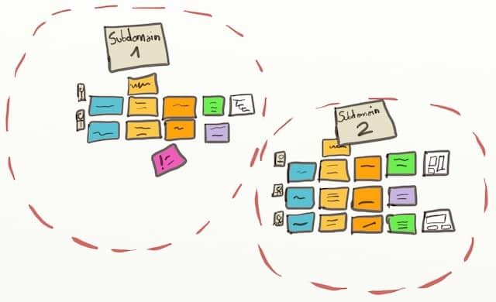

Drawing of 2 subdomains drawn around aggregates on a Design-Level Event Storming board

📝 Aggregates already group events together. Aggregates make it easy to draw subdomains.

Here is a design quick-win you can do before everybody leaves the room. The bounded context you worked on might be large, and not all of it might be equally business-critical. So, **if you can spot areas of higher importance, everybody will know better where to focus their efforts!** DDD calls this the Highlighted Core. The smaller the core subdomain, the more precise the priorities will be.

#### 4.4.4.2 Create curated views

Alberto Brandolini, the inventor of Event Storming, said its **actual outcome is in the participants’ shared understanding. This is true, but it might not satisfy everyone in your organization.**

A quick fix is photographing the design board and saving it in your knowledge base. Another is to stick the board in the team’s space. Yet, you’ll see that the design board will soon become obsolete!

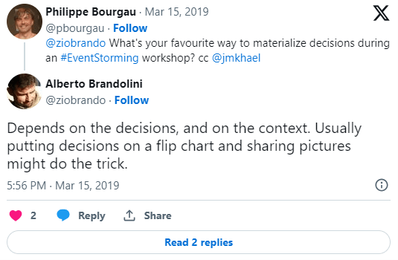

Screenshot of a Tweet from Alberto Brandolini answering the question “What’s your favourite way to materialize decisions during an Event Storming workshop?” His answer is “Depends on the decisions, and on the context. Usually putting decisions on a flip chart and sharing pictures might do the trick.”

A better way is to **capture focused views. For example, domain definitions, problems, and decisions can be collected through specific documents**. For more details, check out [How to Capture the Outputs of an Event Storming Workshop](https://philippe.bourgau.net/how-to-capture-the-outputs-of-an-event-storming-workshop/) and [5 Views to Capture the Outputs of an Event Storming Workshop](https://philippe.bourgau.net/5-views-to-capture-the-outputs-of-an-event-storming-workshop/).

📝 You can even push the curated views idea further and fill a whole [Bounded Context Canvas](https://github.com/ddd-crew/bounded-context-canvas). It’s a precise set of views that, together, will give you a deep understanding of your bounded context.

#### 4.4.4.3 Run example Mapping

All the **business rules are great candidates for user stories.** [Example Mapping](https://cucumber.io/blog/bdd/example-mapping-introduction/) is a quick and structured conversation format for digging into the details of a user story. **Pick a business rule and run an Example Mapping session to turn it into a detailed user story with test scenarios and acceptance criteria.**

#### 4.4.4.4 Build a walking skeleton

📝 The best way to get more feedback after a Design-Level Event Storming is to try to build the design!

Finally, the best way to get more feedback is to try your design! **Building a Walking Skeleton is the most effective way to learn more about your design.** A walking skeleton is a very minimalistic end-to-end implementation of your system or feature. Learn how to select what to put in your Walking Skeleton in [How to fight priority paralysis with Event Storming](https://philippe.bourgau.net/how-to-fight-priority-paralysis-with-event-storming-and-ddd/).



A picture of a walking skeleton. Design-Level Event Storming is the perfect workshop for agreeing on the scope of a walking skeleton

### 4.4.5 Event Storming the Flow

Here you are: You went from a Big Picture idea to a functional architecture and then dived into the details of your core Bound Contexts. You harnessed collective intelligence and tackled a complex business problem to achieve this.



Photo of a monkey watching itself in a mirror. Now that you are good with Event Storming, you can apply it to your workflow!

What if you tried applying this new skill to your workflow? We’ll see that in the next part, Event Storming the Flow. Read on!

# 5 Event Storming the flow

## 5.1 Three questions to know if event storming the flow could help you

*Event storming can be used to improve the flow of work. Answer 3 questions to know if the technique is your go-to choice to address your workflow challenges.*

### 5.1.1 The story of a team that was performing

The Genesis team is working on a software product. The team was once famous for its capacity to respond to client requests extremely fast. Yet, during the last year, each time they received such a request, their work always ended up generating new issues: regressions on the existing code, workarounds that are more and more complex to find, more time dedicated to testing and fixing the regressions than to implement the actual solution.

Although Genesis team members still wished to answer client requests fast, it seemed that a mystery spell had been cast against them. **This situation felt as stressful as being trapped in an ever-growing snowball running downhill with no idea on how to stop it.** The more they wanted to bring back their capacity to respond to client requests quickly, the longer it would take them.

### 5.1.2 The story of a team that was anticipating market needs

The Moonraker team is working on another software product. Not long ago, Moonraker people were assigned a task to anticipate a future market need, based on strategic analysis from product people in the management.

Moonraker guys started developing a new component (*let’s call it ‘error handling’, although we don’t really care about what it is for the purpose of this chapter*). It took them 1,5 years to design, build, and test the first version. The good news is that it coincided with the moment when the first client use case was identified. The bad news was that the volume of ‘errors’ that the ‘error handling’ component should have handled for this client was way higher than what it was meant to be. As the client use case needed to be covered quickly, **an architectural decision was made to have the client-facing team (another one) build a local workaround for this specific client**. Although the client would be satisfied, it was a ‘cosmetic gesture’. The decision clearly acknowledged that some technical debt was created and would need to be repaid.

When a second client use case was identified, Moonraker people had started to work on other quite urgent stuff. Consequently, Moonraker could only dedicate time during the next 4 weeks to address this new request for the new use case. Although there were still some questions on the level of performance for error handling, the plan to dedicate a limited amount of time seemed acceptable, as the new request was documented with a design to implement. Moonraker people started to work right away. A commitment by the client manager was made to the new client.

We are now one week away to the delivery date. Moonraker people made assumptions with regards to the targeted performance level. They are under pressure to deliver on time, while still taking care of their other urgent stuff. They are raising the question. **What is the plan B in case we are late or our assumptions are wrong?**

### 5.1.3 Why are these stories similar?

These stories have **three aspects in common**

1. **The problems that they describe are not about a lack of skills**

The skills, experience, and knowledge of the team members are unquestionable. The teams have all the necessary skills and experience to deliver the products they are working on.

1. **The problem persists**

In both cases, the sensation of a snowball running downhill is present. For Genesis, no matter what they do, it keeps taking them longer to answer client requests. For Moonraker, no matter what they do, they have difficulties to build a solution that corresponds to the needs. There is a risk for them to lose the trust of their stakeholders.

1. **There is no obvious solution**

When reading these stories, you probably identified a few possible dysfunctions. For example, Genesis probably did not take care of their accumulating technical debt early and continuously enough. Or they may do testing too late in their workflow. Moonraker started their new work assignment with no real client use case, which is probably a recipe for failure.

These hypothetical dysfunctions are probably real. Having said that, you can not be sure that these are the only dysfunctions or even the main ones. Besides, you can hardly know what may have caused these dysfunctions in the first place. And even if you could determine a clear set of causes, it is more valuable to identify what to do to change these dysfunctions than to identify their causes.

### 5.1.4 What would an event storming the flow workshop bring?

When you do an event storming of the flow, you will visualize the events that occur during the flow of the work you are examining.

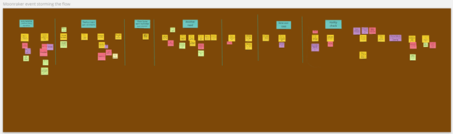

Drawing of an Event Storming the flow board.

Then you will look for patterns and [feedback loops](https://less.works/less/principles/systems-thinking).

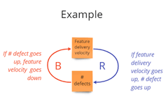

A simple representation of reinforcing and balancing loops with 2 stocks or variables

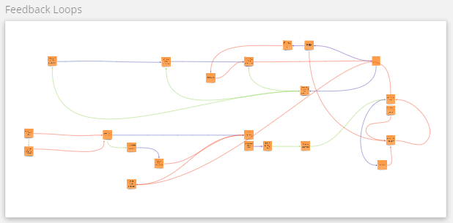

A real life example of a loops diagram, showing a set of variables and loops and how they link together (labels are blurred for confidentiality)

From there, you will identify levers where to act.

This will allow you to you to identify actions. These actions aim at changing the system that creates the repetitive patterns resulting in the events. Starting with visualization and doing the next steps allow you dig into the system and to not stay on the ‘apparent problems and solutions’ that only contribute to perpetuate the snowball effect.

### 5.1.5 How to know if Event Storming the Flow could help you?

In a nutshell, whether your team is working on a software or not, the typical situations in which event storming the flow makes sense are the ones where your answers to the 3 following questions would be no, yes and no:

1. **Is it a problem of skills?** *no*
2. **Has the problem been persisting or even growing despite the effort you or your team already put into solving it?** *yes*
3. **Is there one obvious solution?** *no*

If your answers correspond, read further and get ready to run an Event Storming the Flow workshop on your own!

## 5.2 Five ingredients to prepare before starting an event storming of your workflow

*Event Storming the flow workshop requires 5 main ingredients in the recipe. Get ready to cook in this chapter!*



A picture of fresh vegetables ready to be cooked

In the previous chapter, you answered 3 questions to know if Event Storming the Flow could help you.

You know the challenge that you are going to explore:

1. is not only due to a lack of skills
2. persists despite the effort already put into solving it
3. does not have an obvious solution.

Let’s get prepared for the workshop with these 5 ingredients:

1. A flow to explore
2. The right attendees
3. A workshop intent
4. A briefing
5. A real use case

### 5.2.1 First ingredient: a flow

What is the flow that you will be looking at during the workshop? In other words, in which flow is the challenge embedded?

**A flow consists of a succession of activities linked one to another (think of an assembly line)**. Most of the work we do is part of a flow. In software development, this flow often includes design, test, development, and build activities.

The answer to the previous question goes like this: “the flow that we will be looking at starts from the moment when… till…”.

### 5.2.2 Second ingredient: the right attendees



A sports team hugging together in circle representing an engaged team of people who will be on the pitch

You want to **invite**: - the people **who do the work in the flow** that you identified in the previous question - the people for **whom the problem is painful** - the people **who are volunteering** to attend such a session. It means that they want to contribute to removing the problem.

You want to avoid forcing people into the workshop for a problem that they don’t feel concerned about.

You also want to limit attendance to a decent number of people (10 is already a lot!).

### 5.2.3 Third ingredient: a workshop intent



3 darts with the extremities touching each other

What would the participants like to achieve with this workshop? **Define this intent with as many attendees as possible.**

Ask them to answer questions such as: “What is the intent of this workshop? What do you want to achieve at the end of this workshop? How will you know that you achieved this result?”

**Unprecise intents such as “engaging people” or “improving collaboration” are worth further questioning.**

An intent is like a lighthouse for the workshop. It is necessary to know where to go. It needs to be precise enough to focus. And it needs to be flexible enough to be reached from any starting point. E.g.: “adapt the way we are working together so we have fewer late detections of bugs that provoke rework”.

It’s best when the intent somehow relates to the problem to solve.

### 5.2.4 Fourth ingredient: an introduction of Event Storming the Flow in a few words

Let’s be honest, the name of the technique - event storming the flow - is not self-explanatory.

Yet, there is nothing complex about the technique. You can explain it in a few words: - during a 15min video call or - in a wiki page with examples or - in a short email.

Here is an example of the latter:

Welcome!

You are invited to a workshop called “Event storming the flow”.

What is event storming the flow?

1. **It is a visualization technique** that has been used in the company on several occasions.
2. It aims at **creating an aligned understanding of a workflow**.
3. Once the alignment obtained, the technique allows the **improvement of the workflow**. For example: how to remove priority blockers? What are the sources of rework? When to take better decisions in our flow?

What is going to happen during this workshop?

**This is a collective workshop**, as the list of recipients of this email indicates. **We’ll use plenty of stickies** and follow some simple guidelines to visualize your workflow on a wall. To do this, you will select a real use case that is representative of what usually happens for this workflow. Then, based on this visualization, you will identify: - patterns you wish to remove from this workflow, - levers on which to act to drive the desired change, - and actions to perform.

This is not one of these boring workshops. You will be actively contributing most of the time!

You can also:

* add information about the timing, duration, and the number of sessions,
* provide details about the use case (5th ingredient) or the workshop intent (3rd ingredient),
* share this book, or a link to some posts from the [Event Storming Journal](https://eventstormingjournal.com) blog that inspired the book!

Your goal is to **convert a name (event storming the flow) into an attractive promise for attendees**.

### 5.2.5 Fifth ingredient: a real use case

**The participants will bring a real use case as a starting point to describe the flow.**

Ask them for a **recent** feature or situation. It needs to be **representative of what usually happens in the workflow**.

Using a **real-life situation** is key to:

* **prevent theoretical discussion** about an imaginary situation
* **engage the participants** who can discuss a use case they know
* **identify a bounded scope** for the workshop
* check that you have **the right list of participants** to cover this scope

Having the use case before starting the workshop is not a must. Still, it is a good way to check the alignment of the participants.s

It’s a good sign when several people identify one. Otherwise, it is an opportunity to take a step back and go back to the intent of the workshop again (3rd ingredient).

### 5.2.6 Conclusion

If you follow these steps, your Event Storming the flow session is already on a good track! In the next chapter, we’ll see how to visualize a workflow.

## 5.3 The steps to visualize your workflow with Event Storming

*When you have recurring problems with how work is performed, Use Event Storming to model your workflow. It is the first step to changing the status quo.*

This chapter is a step-by-step guide to running your event storming the flow. Go straight to the steps if you are short on time.

Read the whole chapter to discover:

* The typical situations where Event Storming the flow is a good fit
* Why visualization works great
* Why Event Storming the flow is an awesome technique

### 5.3.1 Typical situations for which Event Storming the flow is a good choice

In a previous chapter, you read the stories of 2 teams creating software and having problems doing so. These problems:

1. were not about skills
2. were persisting over time
3. had no obvious solution

### 5.3.2 Visualization? Why?

These situations are complex as there is no obvious causality of the problem.

In complex situations, a good first step is to start with a visualization of your workflow.

This means modeling and visualizing what usually happens (events) on a timeline. When you do so:

1. You focus on facts, not theories or opinions
2. You start with a description of a situation to understand the problem. You don’t state the problem by the lack of one’s favorite solution. e.g. “the problem is we don’t spend enough time on [*whatever*]” or “the problem is we have no contact with [*whoever*]”
3. You create the possibility to ask: “what made us get there?” and “what is working fine, that we could use as a basis for future progress?”

Thus, visualization:

* helps you find the right actions
* and decreases the likeliness of making the wrong decisions.

### 5.3.3 Why Event Storming?

Event Storming is a very good technique to visualize your workflow because:

1. You do Event Storming with the people who do the work described in the workflow. And it is a collective activity.
2. An Event Storming of a workflow starts with a real-life use case. It neither describes a theoretical, nor an ideal succession of steps.

Read more about the benefits of using Event Storming for visualization in [this blog post](https://philippe.bourgau.net/event-storming-lessons-from-post-it-haters/)

### 5.3.4 The step-by-step guide to model your workflow with Event Storming

#### 5.3.4.1 Preparation

* Gather the 5 ingredients to prepare your event storming the flow
* Find the ideal room to run the workshop
* And prepare the room

#### 5.3.4.2 Find a use case to describe

You can identify this use case before the workshop or at the beginning of it. To do so you can ask this question:

What is a topic you recently worked on, that you would qualify as quite representative of how the work is performed in this team / area / department?

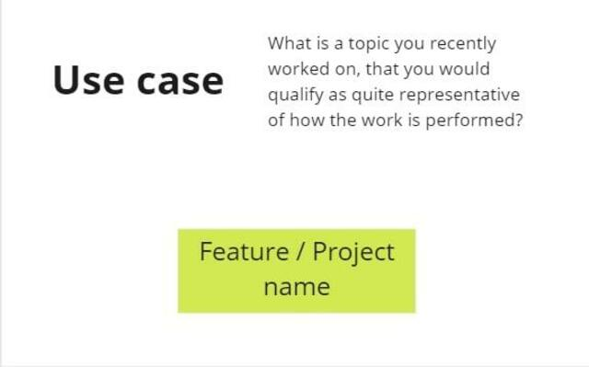

Screenshot of the board on which the initial use case is identified

Usually, people mention examples like “the [*feature name*]” or “when we did [*a project requiring a significant effort*]”

Whatever the use case is, you want the workshop participants to consider it representative. If someone proposed the use case before the workshop, ask the following question at the start of it:

Do you consider this use case representative of how the work usually happens in this team / area / department? If not, what alternative use case would you propose to explore?

Sometimes, you will have to cover several use cases. Each represents a different workflow that usually takes place in parallel in real life.

In this case, model these workflows in parallel on the visual board.

#### 5.3.4.3 Identify an event

Ask people to identify something that happened during this workflow. Give an example such as “feature inserted in the backlog” to show that an event is expressed in passive form and past tense.

You only need an event to start. Write Events on orange stickies.

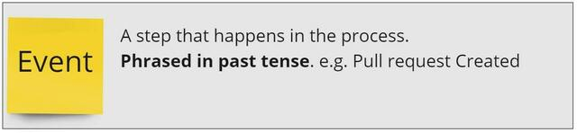

Screenshot of the board with the definition of an event

#### 5.3.4.4 Identify more events, collectively

1. First individually (4’), then in pairs (4’) , then in groups of 4 (5’), ask people to identify more events on stickies.
2. When discussing in small groups, they should remove duplicates, clarify wording, and start sticking the events chronologically
3. Together (5’), invite people to remove duplicates again and align the consecutive events on a horizontal line. If the workflow includes optional paths or alternatives, they should be placed on another parallel horizontal line. Do all this in silence.
4. Then inform the participants that this is the first draft of the visualization. Not everything is clear yet. Some words may be confusing. But the goal is to draw the whole picture before going into details. So, ask people:
   * “What is missing to complete the picture? Are there some gaps in this workflow representation?”
   * “Are there events that occur before or after that have a significant impact on this workflow or that this workflow impacts?”

If the answer is yes, do another iteration starting from 1

At this stage, you will have to ask that someone tidy things up a bit: realign stickies, remove stickies that placed randomly… It should take 2 to 3 min at most. It is better to ask someone than to do it yourself. Do not neglect any opportunity to make the group responsible for their work.

By the way, if you wish the group to feel in charge, benefit from concrete advice by visiting this blog post: [Engage the participants during your next Event Storming thanks to the Delegated Missions](https://www.eventstormingjournal.com/foundations/engage-the-participants-during-your-next-event-storming-thanks-to-the-delegated-missions/) presents a good approach (“the delegated missions”) to do so. It is called the delegated missions.

#### 5.3.4.5 Identify hotspots and actors collectively

##### 5.3.4.5.1 What are hotspots?

Hotspots are spots of the workflow that are hot 😉. Write hotspots on red stickies. People will identify with these stickies:

1. Things that are not clear (e.g. the meaning of a word)
2. Questions (e.g. “How was this decision taken? By whom?” “How long did this step take?”)
3. A problematic area or pain point (“This puts more pressure on the teams”)
4. They may also write down suggestions (e.g. “what if we had done this with our product owner involved?”)

The goal of sticking a hotspot is to flag that something needs discussion or to park discussions for later.

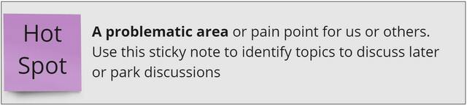

Screenshot of the board with the definition of a hotspot

##### 5.3.4.5.2 What are actors, and external systems?

Actors are the people who contribute most to the occurrence of an event or a chain of events. Use small blue stickies to identify actors and stick them on the 1st event.

You can use the same stickies to identify interactions with external systems, sources of information, or people.

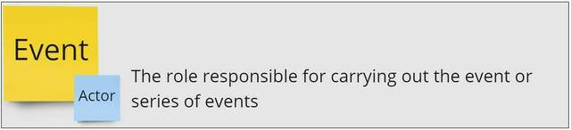

Screenshot of the board with the definition of an actor

##### 5.3.4.5.3 How to identify hotspots and actors?

1. Split your attendance into 2 groups.
2. One half identifies actors while the other identifies hotspots
3. 5’: ask people to identify hotspots or actors individually and in silence without sticking them yet
4. 5’: in small groups of 3 or 4, people share their list, remove duplicates, refine, and stick their actors or hotspots.
5. Switch the groups. The group who was on hotspots goes to actors and vice-versa
6. 2’: ask people to individually look at what was previously displayed
7. 3’: back in small groups of 3 or 4, people remove duplicates they see and enrich the initial list with their contribution if they want to add any hotspot or actor

#### 5.3.4.6 Final check

You should now have a representation of the workflow that looks something like this:

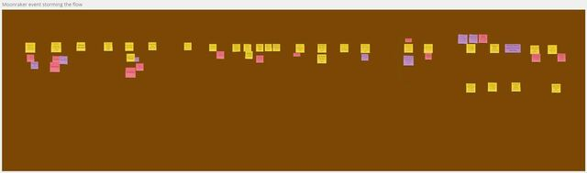

An example of an event storming the flow

But before going further:

* Re-confirm the use case is representative of the usual workflow by asking the question:

Now that you represented the use case, would you still say that it is representative of how the work is performed in this team / area / department? Or would you suggest another more representative use case?

* Check the picture encompasses enough of the system by asking:

In the next steps we are going to identify improvements and challenge how the “system” works. How representative of the whole system is this visual? Would you advise adding more steps to the left or to the right to enable us to be bold in the next steps?

These 2 checks can open the door to going back to more visualization activity.

### 5.3.5 Conclusion and next

Once you visualize the workflow you are one step further toward alignment on the problem.

What you already achieved with the group is:

1. a shared understanding of how work is performed. This resolves lots of opinion-based debates.
2. an identification of what is not explicit enough (hotspots).

You also opened the possibility of broadening the boundaries of your actions. You can enable the diagnosis, based on something tangible.

We will explain how in the next chapter.

*In case you are wondering, you can do all the above remotely. We will come back to this in a* *future chapter**.*

## 5.4 How Metaphors can help you focus and succeed in Event Storming

*You modeled your workflow with Event Storming. Now use a metaphor to give a name to this model. This chapther explains how and why this is good practice.*

A picture is worth a thousand words.

When it comes to understanding complex business processes, a metaphor can be worth millions.

The previous chapter describes the steps to visualize a workflow with Event Storming. The resulting visualization looks something like this.



The big picture of an event storming the flow representing a succession of events written on stickies

Let’s call this visual model the “Big Picture”.

It is now time to take a step back to digest what you see.

You can do this in 3 steps:

1. Identify the main steps of the workflow on the Big Picture.
2. Get insights from looking at this enriched Big Picture .
3. Give a title to your Big Picture.

These simple steps are describe below.

Putting a title to your Big Picture is an easy and fun activity that brings important benefits. You can read the list of them at the end the chapter. For example, having a title allows you and your team to name what it is that you want to avoid.

But let’s first go back to the Big Picture.

### 5.4.1 One.- Identify the main steps of the workflow on the Big Picture

Start by asking the participants to:

* Find clusters of events that fit well together.
* Define a name for each of these clusters of events.
* Draw a vertical line between each step. They can use tape or draw lines on a digital tool. Now, your Big Picture should look something like this:

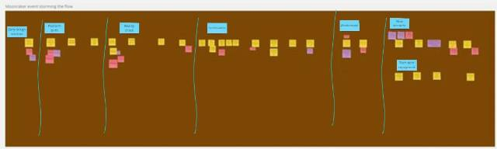

A workflow represented on an event storming with main steps separated by vertical lines and a title for each of the steps

### 5.4.2 Two.- Get insights from looking at the Big Picture.

The previous step made the Big Picture more digestible. Now that it has some structure, it is easier to step back and not get lost in the details.

Ask the participants the following questions:

What are you noticing? What does this picture show? What are your thoughts and feelings? What seems to be a recurring pattern? Where do you see activities that create unproductive results?”

Give them 3 minutes to think alone, then ask them to join in a group of 2 or 3 and discuss their thoughts for 5 minutes.

Once done, ask the whole group to voice some of the things that they shared in their discussions. Don’t let this go on and on. Timebox this discussion to 5 minutes max and try to get as many different inputs as possible.

### 5.4.3 Three.- Pick a title

Now comes the fun part!

Use the following prompt:

Based on your discussions, now find a name for your Event Storming. It can be a name you invent, a song title, or the title of a famous movie. Be creative and have fun!”

Ask participants to think alone for 1 min. Then, in groups of 3, ask them to come up with a proposal and stick it on the wall.

Use dot voting to select the best proposal. Ask participants to:

Select one of the proposals. Pick the one that you would mention, to remember what you want to stop! For example, you could say: “guys, we are doing [ title ] again”.

*Back to the Future, Groundhog Day, and Highway to Hell are classical choices!*



A picture of a groundhog to illustrate the movie Groundhog Day

### 5.4.4 Four.- Why is this activity useful? What are the benefits?

Giving a fun title for your workflow may seem trivial. Yet, having a name to refer to, that represents what you want to avoid is very useful for several reasons:

1. You can mention it when falling back to the undesired pattern.
2. It builds a common language over what your group wants to avoid.
3. With a song or movie name, you do not make a drama of the undesired situation but rather make fun of it.
4. The simplicity of the metaphor prevents digging further into the analysis.

This 4th benefit is key as, at this stage of the Event Storming, what you want to do is to start looking for possible ways to improve your workflow.

How to do this? Keep reading! This is what we will discuss in the next chapter!

## 5.5 How to discover the wicked vicious circles in your workflow?

*Stuck in repetitive workflow issues? Learn to spot and fix vicious cycles with this practical guide.*

### 5.5.1 Vicious circles?



Two goats fighting to illustrate a typical useless fight.

It was during last Christmas lunch, or during any Sunday family event. Your uncle Dave and your brother-in-law Bob started to discuss. The discussion was about Covid (or the education system, or the level of taxes, or the choices of the national football team coach). What you clearly remember is the overheating tone and the strong opinions that would never converge.

You can see the picture, right? We all witnessed such an opinion-based conversation… And let us be honest, we even took part in one of them. Most of these conversations go nowhere.

Yet, what they illustrate is the following: we all think we excel at knowing “what the real problem is”. We all believe we are excellent at identifying root causes of dysfunctions. Every one of us has an opinion about “why things are not working properly”.

The truth is, we are quite good at finding causes of dysfunctions. Yet, while each root-cause contributes to a dysfunction, there are plenty of causes to problems that are complex by nature. So, we all can point at one or two causes and easily think is THE problem. But what if there were plenty of root causes, and what if they were highly interrelated?

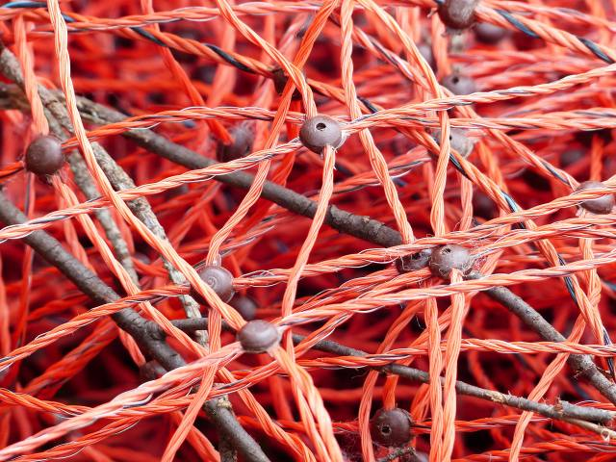

Image of a fishing network to illustrate how causes are linked together.

This is what is happening when you are on a journey to improve your workflow: - You want to identify the root causes of the dysfunctions and fix them. - The bad news is that there is more than one root cause. There are plenty of them. - And the worst news is these root causes are all linked.

Fortunately, this chapter shows you how to visualize links between the many causes and consequences. In case you want to know, this visual representation mobilizes basic concepts of systems modelling. But don’t worry and keep reading, it is simpler than what the name indicates!

Visualizing your workflow is an entry door to identifying the vicious circles in your workflow. Remember the overheated conversation between Dave and Bob. The vicious circle probably started when Dave answered Bob with a strong opinion-based statement, to which Bob counter-attacked, making Dave pump up the volume, etc.

Here, you have what is called a causal loop: a cause, creating an effect that becomes a cause to another effect and so on, in a loop.

We call this type of causal loop a vicious circle because it has undesired effects that often persist over time.

Causal loops are present in your workflow. Let’s see how to identify them.

Here are the steps:

* Step 1: Introduce the concept of *Variables*
* Step 2: Have the participants identify the variables of the workflow.
* Step 3: Introduce the concept of *causal loops*.
* Step 4: Create a simple causal loop diagram.

Let us detail each of these steps.

### 5.5.2 Step 1: introduce the concepts of variables.

For example, you can say: > “Variables are characteristic elements in your workflow that can change or impact the overall process, for example: > - Number of people involved. > - Time to take a decision. > - Time to get feedback. > - Time to correct. > - Work in progress.

Variables are things that you can measure or observe. They can be quantities, duration. They can also be information in a broad meaning, or characteristics of relationships.

They influence how your workflow operates. We use variables to help us understand the different factors at play in your workflow.”

### 5.5.3 Step 2: Have the participants identify the variables in their workflow .

As you introduced the concept of variables, now ask the participants to identify the variables for the workflow.

* Give them 5 minutes alone to list these variables on stickies.
* Ask them to join in groups of two for 5 minutes.
* You can potentially do another round by having groups of two merge to form groups of four.
* Have them display the list of stickies on the wall.

Tip: if participants get blocked at the start, show them a list of potential variables, for inspiration.

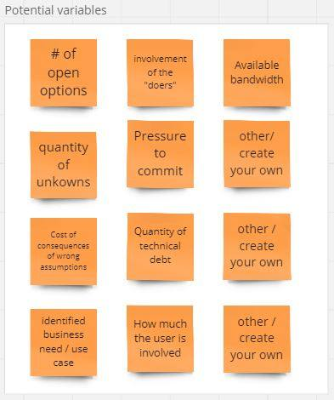

Examples of variables such as avialable bandwidth or quantity of unknowns or pressure to commit.

At each round, ask participants to:

* Remove duplicates.
* Clarify the name if it is not self-explanatory.
* Check that all variables can be measured or observed. Reformulate and find the variable otherwise.
* Extend the initial list. Ending up with a list of 5 to 15 variables sounds realistic.

### 5.5.4 Step 3: explain the concept of causal loops.

A bit of storytelling is welcome here:

“Suppose you invest one hundred € on an account with a 5% annual interest rate. After a year you own 105 €. After 2 years you own 110.25 €, etc. The more you invest, the more extra capital you get. And the more extra capital you get, the more you can invest. It is a **reinforcing** loop.

Let us take another example. In a retail store, as stock levels decrease due to sales, the store places orders to restock inventory. It is a **balancing loop**. Less stocks -> More orders -> More stock

Reinforcing or (positive feedback loops) can lead to exponential growth or decline, while balancing loops (or negative feedback loop) tend to maintain stability. They often interact.”

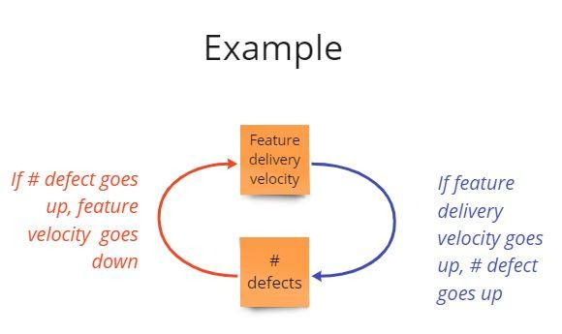

Example of a causal loop with feature delivery veloivty on one side and number of defects on the other side.

### 5.5.5 Step 4: Create a simple causal loop diagram.

Your role now, as a facilitator, is to have participants draft causal feedback loops between the different variables they identified in the previous step. To do this, our advice is to do an example with them.

Pick a variable from their list randomly. Suppose you pick “Work in Progress”.

Ask them:

“if you have more Work in Progress, what other variable will be affected?”. “Time to correct a defect” could be one.

Then ask them:

If “Time to correct” is higher, what will increase? They will probably say “Work in Progress”, or something else.

Use the color coding from the previous image. Red for reinforcing loops, blue for balancing loops, green when the direction is unknown

In small groups of 3 to 5, ask participants to continue this activity by adding variables and relationships.

The goal of this activity is not to reach the perfect model of their workflow. Systems modeling is a whole discipline that we are simplifying for our purpose.

Yet, you will quickly observe each group adding variables, loops, and a shared visual taking shape.

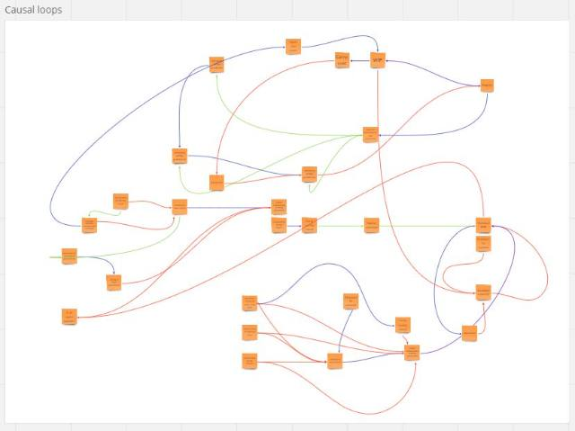

Example of a causal loop diagram showing links between variables.

Once this happens, ask participants to check that the links they placed are as direct as possible.

Ask them to erase the ones that could be more direct, or to identify new intermediate variables.

If “A” indirectly affects “C”, would there be an intermediate variable “B” between “A” and “C”? For example, between “Work in Progress” and “Time to correct a defect”, there could be an intermediate variable “Time to acknowledge the defect”.

As mentioned, the goal is not to reach perfect accuracy of the model. The next chapter explains how to identify the levers to act upon. You will understand the value of having a “good enough” model when reading it.

### 5.5.6 Bonus extra step: Take a step back and have participants share their learnings at this point.

At this stage, participants may already have come to striking realizations while stepping back on how their work is organized.

The high inter-relatedness of root causes is likely to be one of them!

If you feel the energy is a bit low in the room, give participants 1 min to individually identify their learnings at this point, and ask a few of them to share their reflections. This usually boosts the energy to continue.

## 5.6 Identify where to act to improve your workflow

## 5.7 Event Storming the flow in 3 minutes

# 6 Remote facilitation

## 6.1 Rethinking Event Storming in remote

## 6.2 References to go further

# 7 General tips for Event Storming

## 7.1 The ideal room for your in-person Event Storming

*How to make sure you select the right room (and avoid the wrong one) for your in-person Event Storming? Use the below checklist!*

We did one of our first event storming with a team who was trying to envision a target architecture.

We had a very good relationship with the architect and the team members. So, when we offered to try Event Storming with them, they all said yes. We jumped into the wild and learned the hard way that **a room can make or break your event storming!**

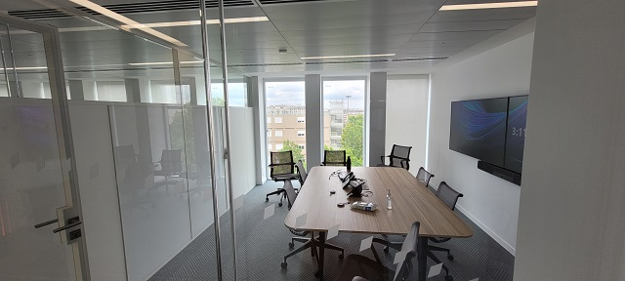

A 6x4m room with a big central table and glass walls

The room we booked was like the one the picture. Size: 6m x 4m, with a big unmovable table in the middle, a window on one side, a screen on another wall, and a window. This only left one available wall for our event storming. Unfortunately, the wall surface was asperous. The adhesive tape was not sticking onto it. The kraft paper fell several times!

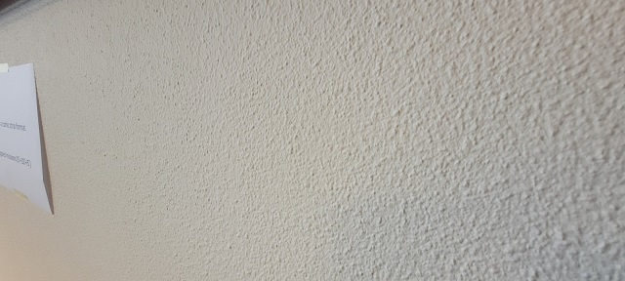

An asperous wall on which posters don’t stick

Due to a lack of space to move around, the 10 participants had to stay packed in front of the wall. The room temperature started to rise. We opened the window to get some fresh air but got the street noise instead. We had to open the door and, as a result, hide a part of the event storming. Then some participants spotted the comfortable chairs and decided to use them.

**Bottom line: this first experience was rather “amateur” and participants disengaged themselves quickly.**

**Hopefully, after reading this chapter, you should not reproduce our rookie mistakes!**

The following checklist will help you pick the right room. This list is applicable for any kind of event storming (big picture, design level or event storming the flow) as the room settings is similar in all cases.

### 7.1.1 What you want for your room is:

* A long wall: aim at 5m minimum – more is better (Alberto Brandolini mentions 8m!).
* Other walls to stick posters
* A room that is big enough so people:
  + can step back (physically) to look at the long wall
  + feel comfortable and not squeezed
  + can move around without being blocked by others
  + can find a space to gather in smaller group for a few minutes
* A room that is not too big so people are less likely to keep physically distant from the main wall. As a rule of thumb, **if the participants are standing between you and the wall, you should still be able to read the tickets** if written with block letters.
* A room with windows to let light and air come in. You want participants to be able to breathe and open their minds!

### 7.1.2 What you don’t want is:

* A room with plenty of digital screens. You won’t need them as you won’t do any presentation. Apart from this, having screens keeps the walls busy and is likely to distract people from having conversations.
* A room with glass walls
* An open space through which outside people can walk
* A room that gets hot or with low ventilation. Participants will stand up most of the time. They will move around and be standing together in front of an area of work on a wall. This is not possible when you get hot or start to sweat!
* A room that is very bright. We had a case where the room we used was filled with natural light and big windows. It proved to be problematic as it was a source of visual fatigue.
* An island table in the middle. You should look for a room where chairs can quickly be moved around and where tables are pushed on the side for people to put their bags, cups and personal stuff.
* A room with pillars and other physical barriers.

### 7.1.3 In a nutshell

As mentioned, in our experience, the room is an important enabler of the success of in-person event storming workshops.

Basically, it boils down to: **“a room with at least one long wall and enough space for people to move around. Not a fancy/modern one but rather a simple space without chairs or table in the middle”**.

### 7.1.4 What’s next?

Once you booked the right room, you can refer to other chapters in this book: - Use this other checklist to prepare the room when running an event storming - Or use event storming for workflow improvement.

## 7.2 Going Further with Event Storming

# 8 Conclusion